Earth Conservation Unit

The purpose of this unit is to provide multiple KAT resources to integrate at any point throughout the school year to gain a deeper understanding of the Earth and why we need to take good care of it.

Table of Contents
KAT READING COMPREHENSION INSTRUCTIONAL GUIDE© 3
Writing Prompt Ideas: 5
Persuasive with source text 5
Paired text comparison prompt: 5
Passage: 12 Biggest Environmental Problems Of 2022 1
Global Warming 2
Politics 6
Food Waste 7
Biodiversity Loss 8
Plastic Pollution 10
Deforestation 11
Air Pollution 12
Melting Ice Caps 13
Ocean Acidification 15
Agriculture 18
Food and Water Insecurity 20
Fashion & Textiles 22
Unit Resources 23
File library resources with links: 23
Vocabulary: 27
Other Resources 40
Book ideas w/o a KAT guide: 40

KAT READING COMPREHENSION INSTRUCTIONAL GUIDE©
This page must be completed for every text students read.
Story/Article/Chapter: Story/Article/Chapter: 12 Biggest Environmental Problems of 2022
By Deena Robinson from Earth.org
https://earth.org/the-biggest-environmental-problems-of-our-lifetime/

Student Handout: https://itss.literacy.io/TeacherLibrary/Files/ViewPublicFile/8e69b1b0-33bc-4ceb-a1de-0da72e268cbf

Note: Please see the end of this guide for teaching suggestions of this lesson
TEKS/CCSS: {Please list any standards that will be addressed throughout the lesson with this passage}
Text Structure(s): {Identify if cause and effect, problem and solution, and/or comparison text structures organize the text}
Overall: Comparison
Individually: most of the passages are cause problem solution or cause/effect

CHECKPOINT #1: INTRODUCTION
Make sure to introduce the text structure as you introduce the reading w/o explicitly stating text structure
Introduction to lesson:
In honor of earth day this month we are going to be investigating the problems the earth faces. As we read, I want you to pay attention to what are the problems? Why does the earth have so many problems? Why are these issues occurring? And is there anything we can do to stop it?

CHECKPOINT #2: VOCABULARY
Identify important, useful, or difficult words that are essential to comprehension
BOLD words to teach before, ITALICS monitor, UNDERLINE after
Try to focus on Tier 2: {High-frequency words across contexts; used more in writing than everyday speech} and Tier 3: {Low-frequency words; domain specific}
*Note: There are a LOT of vocabulary that might cause students problems in these passages. I would consider previewing each text before assigning them to students. You might even want to adjust the wording of some of tehh passages to use in your younger grades. Please see the vocabulary chart at end of unit for common words to review.
Signaling Words in Passage: {Identify words or phrases that clue the reader to the text structure and key ideas}
Negative impact, caused by, effects, in danger, we can, people need to

CHECKPOINT #3:MAIN IDEA
{Make sure to use the text structure specific main idea stem that matches the overall text structure for the passage. For example, for cause and effect use: The cause is _____ and the effect is ______.}
OVERALL Main Idea/Key Idea/Central Idea for the whole passage:{Use sentence stems: For example, for cause and effect use: The cause is _____ and the effect is _____}

The 12 biggest environmental problems in 2022 are compared on what causes these problems, the negative effects of these problems, and possible solutions.

Multiple Choice Question Practice {Create a multiple-choice question asking students to select the best main idea} [The correct answer is in red.]

What is the BEST main idea of the ENTIRE selection?
A. Humans need to make major changes if they want to correct the negative impacts affecting earth.
B. Earth’s most dangerous environmental problems have a variety of causes and humans must act fast to make change happen.
C. Global warming is earth’s most dangerous environmental concern.
D. There are plenty of changes humans can make to save the earth.

Section/Chapter/Paragraph Main Idea/Key Idea/Central Idea
Global Warming
The cause is emissions of fossil fuels and the effect is rising temperatures leading to catastrophic events.
CHECKPOINT #4: SUMMARY
{Copy and paste the main idea statement here. Extend the main idea by including details supporting each part {e.g., cause, problem, and solution. Write your added details in red.}
Summary for the whole selection:

The 12 biggest environmental problems in 2022 (e.g., global warming, food waste, biodiversity, plastic pollution, deforestation, air pollution, melting ice caps, ocean acidification, agriculture, food and water insecurity, fashion/textiles, and politics) are compared on what causes these problems such as being wasteful, using more resources than the earth can reproduce, and plastic pollution, the negative effects of these problems such as disrupting ecosystems, contaminating water and air, and extreme weather conditions, and possible solutions such as using renewable energy sources, rebuilding forests, making lifestyle changes to reduce unnecessary consumption.

Multiple Choice Question Practice {Create a multiple-choice question asking students to select the best summary.}
Which detail offers support for the author’s suggested solution?
A. Global warming is the most pressing environmental concern of our time.
B. The scientists say that without the human destruction of nature, this rate of loss would have taken thousands of years.
C. We need to rethink our current food system; switching to a more plant-based diet would dramatically reduce the carbon footprint of the conventional agriculture industry
D. The global demand for fashion and clothing has risen at a unprecedented rate that the fashion industry now accounts for 10% of global carbon emissions,

CHECKPOINT #5: INFERENCE
Create inference questions that ask the students to infer by examining the evidence to support their answer.
Inference Questions: {Include both open-ended and m/c questions. Use the STAAR sample question stems if needed}

Open-ended
1. What could the author have added to make his opinion more convincing?

Multiple choice [Use this space to create a multiple choice inference question often found in standardized tests. Please use the sentence stems resource to help word the question in the same testing language]
1. With which statement would the author most likely agree?
A. Plant based diets lead to healthier bodies.
B. Legislation towards conservation has helped the earth tremendously.
C. Fashion and Farming are two industries that need to make major changes to help the environment.
D. Extreme weather conditions are not a result of global warming.

Vocabulary Inference Question: [Use this space to create a vocabulary inference question where the students must return to the text and infer the meaning of the word by using context clues or morphology instruction]
1. Which of the following would be the best definition for the word conservationist?
A. person who advocates or acts for the protection and preservation of the environment and wildlife
B. a person who is averse to change and holds traditional values.
C. an expert in or student of the scientific study of plants
D. an expert in or student of the branch of science concerning living organisms

Note:
B: conservative; C: botanist; D: biologist

This lesson planning page is part of three grant funded projects led by Dr. K. Wijekumar at Texas A&M University. The materials are designed to improve reading comprehension and to be used with the text structure strategy instruction in language arts, science, social studies, special education, and bilingual classrooms. Most importantly, this planning page ensures consistency of instruction

Teacher Notes from Dr. Owens:
This is a higher level reading article, yet it has a lot of information with links to other sources to allow for students to dive deeper.
- If I were teaching this lesson, I would introduce the fact that we are going to investigate problems facing the environment today. I would separate this article into 12 parts.
- I would preview vocabulary for the whole group. I would then model by reading ONE of the passages, identifying and doing a KIMS strategy on unknown words, writing the main idea, extending into a summary, and creating and answering 2 inference questions.
- I would then give the remaining 11 passages to pairs of students and let them complete the activity. We could then share our findings on a matrix, and do one of the suggested writing activities below:

Writing Prompt Ideas:

Persuasive with source text
- The earth is in danger with many environmental problems. Write a speech to your community informing them of the dangers of the environmental concern you researched persuading them to make a change in their lifestyle to help the earth. Use atleast 2 pieces of evidence to support your speech.
- Kids are the future of this planet. Write a persuasive letter to all kids convincing them to become change agents in convservation efforts to save the planet. Use evidence from the text to support your letter.
- Create a persuasive ad (video, poster, text) to inform the public about the concerns facing the planet today convincing them of changes they can make to help save the planet. Make sure to include evidence and facts from the research to make your ad more convincing.
- Read the book Rise Up and Write: https://itss.literacy.io/TeacherLibrary/Files/ViewPublicFile/2fa611da-fc2d-4383-8b94-f9d6981bd0eb
Think about the Farrah and her friends made a difference in their community. After researching the problems affecting our earth, write a letter to a member of government (local or federal) persuading them to get involved and make a change.
Constructed Response:
- Read this statement: “Humans are learning from their mistakes involving pollution.” Do you agree with this statement? Explain your answer using evidence from the video or the text to support your opinion.
- In your opinion, which environmental problem is the most important one facing the earth today? Support your answer with evidence from the text.
Example TREE Plan
T: No humans aren’t learning
R: continue to be wasteful
E: 1/3 of food is wasted
11 millions tons of plastic into oceans/year
E: this demonstrates humans haven’t learned or they would make change

Example TREE CR Answer:
I do not agree with the statement that humans have learned from their mistakes regarding pollution. As the text states, a third of food meant for humans is wasted and 11 million tons of plastic end up in the ocean- EACH YEAR. This evidence suggests that humans are not only NOT learning from their mistakes, but they are actually adding to the pollution problem on earth.

Paired text comparison prompt:
- You will read two passages about problems facing the earth today. You will complete the main idea, summary, and inference questions worksheet. You will then write an informational essay comparing the two problems discussing how these problems are similar and different, and considering various possible solutions to each problem. Support your answer with evidence from the text
- Read the poem and the short passage on plastic pollution. How are the ocean and Sarah’s room similar? Do you think Humans might have a similar fate as Sarah? Support your answer with evidence from the text.
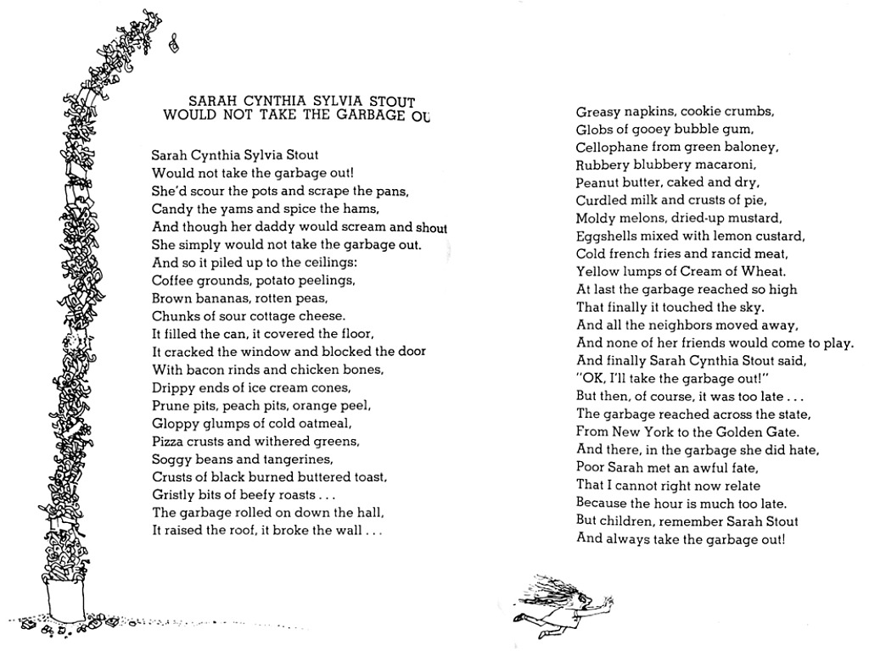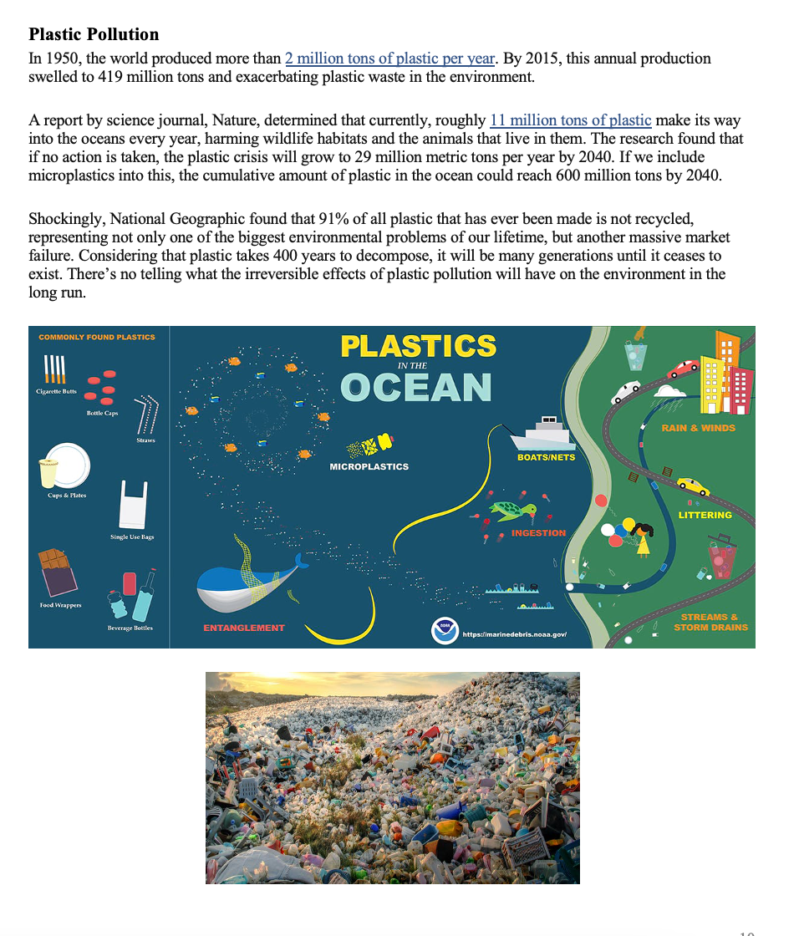
Matrix for entire article is found on the next page

What is being compared? Environmental concerns
 | Causes | Negative Effects/Problems  What are they being compared on? | Solutions
Global Warming | Emissions of greenhouse gases from post-industrial world norms | Rise in temperatures-catastrophic events all over the word: fires, locusts, pollution.  Weather- hurricanes, flooding | Reduce greenhouse gases  Renewable energy projects
Politics | Lack of policies/laws to monitor greenhouse gasses  Or innovation for green practices |  | Countries need to reduce gases with repercussions for non-compliance
Food Waste | 1/3 of food for human consumption is wasted  Food waste and loss  Store level- aesthetic reasons | Greenhouse gases  Food insecurity
Biodiversity | Rapid growth of. Human consumption, population, urbanization  Human destruction of nature | Using more Earth’s resources than it can replenish  Animal population declining  Animal extinction
Plastic Pollution | Produce 2 tons of plastic per year and  419 million tons of plastic waste in environment  Plastic takes 400 years to decompose | Harms wildlife and ecosystems in ocean  90% of plastic not recycled  Unknown irreversible effects
Deforestation | Agriculture | Land cleared to raise livestock/farm  Soil erosion  landslides | Rebuild forests  Tackle deforestation
Air Pollution | Industrial and vehicles emissions, burning biomass, dust storms | People dying with polluted lungs
Melting Ice Caps | Temperature rise-melts ice which rise in sea levels | Impact coast regions- 480 million- would overpopulated other areas
Ocean Acidification | Carbon emissions (fossil fuels), increased wildfires- carbon dioxide absorbed by ocean  Plastic pollution | Change in Ph and acidity  Effect Ecosystems (ripple effect)  Coral bleaching
Agriculture | Fertilizer/soil erosion  Animals on large amounts of land & Consume 2/3 of freshwater | Greenhouse gas  Water shortage | Switching to plant-based diet
Food and Water Insecurity | Rising temp & unsustainable farming  Chemicals | Water/food insecurity  Contaminate water | More sustainable farming practices  Countries need to rethink food systems
Fashion & Textiles | Aviation and shipping  Textile dye  Poor quality clothes produced quickly | Emissions/greenhouse gas  20% of global wastewater  Waste in landfills/not biodegradable | Companies commit to zero emissions by 2050

Passage: 12 Biggest Environmental Problems Of 2022
BY DEENA ROBINSONAFRICA AMERICAS ASIA EUROPE GLOBAL COMMONS OCEANIAFEB 7TH 202213 MINS
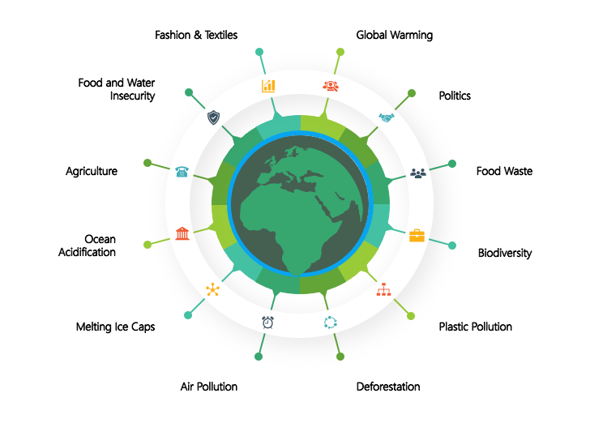

The climate crisis is accelerating at an unprecedented rate, and we are not ready for it. While the crisis has many factors that play a role in its exacerbation, there are some that warrant more attention than others. Here are some of the biggest environmental problems of our lifetime.
Notes: While these are some of the biggest environmental problems plaguing our planet, there are many more that have not been mentioned, including overfishing, urban sprawl, toxic superfund sites and land use changes. While there are many facets that need to be considered in formulating a response to the crisis, they must be coordinated, practical and far-reaching enough to make enough of a difference.

Global Warming
At time of publication, CO2 PPM (parts per million) is at 418 and the global temperature rise is 1.1 degrees Celsius compared to pre-industrial levels.
Increased emissions of greenhouse gases have caused temperatures to rise, which are causing catastrophic events all over the world – from Australia and the US experiencing some of the most devastating bushfire seasons ever recorded, locusts swarming across parts of Africa, the Middle East and Asia, decimating crops, scientists warning that the planet has crossed a series of tipping points that could have catastrophic consequences, microplastic being found in Antarctic ice for the first time, a heatwave in Antarctica that saw temperatures rise above 20 degrees for the first time, warnings of advancing permafrost melt in Arctic regions, the Greenland ice sheet melting at an unprecedented rate, news of the accelerating sixth mass extinction, increasing deforestation in the Amazon rainforest, warnings of air pollution exacerbating the spread of COVID-19, China experiencing its worst floods in decades, methane levels rising to their highest on record, Canada’s last intact ice shelf collapsing, a national park in the US recording the highest temperature ever recorded on Earth, 13% of deaths in the EU being linked to various forms of pollution, a report saying that population sizes of wildlife have experienced an average decline of 68% since 1970 and record-breaking wildfires in California that have blocked out the sun – and these are just a fraction of the events.
The climate crisis is causing tropical storms and other weather events such as hurricanes, heat waves and flooding to be more intense and frequent than seen before. However, a study has found that even if all greenhouse gas emissions were halted in 2020, global warming would only be halted by around 2033. It is absolutely imperative that we reduce greenhouse gas emissions; thankfully, this year is set to see the highest uptake of renewable energy projects around the world.
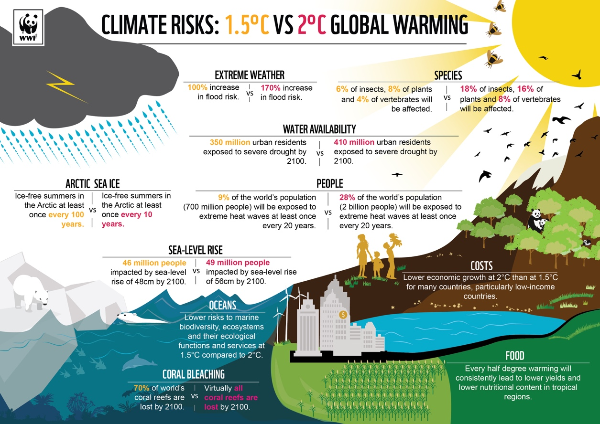
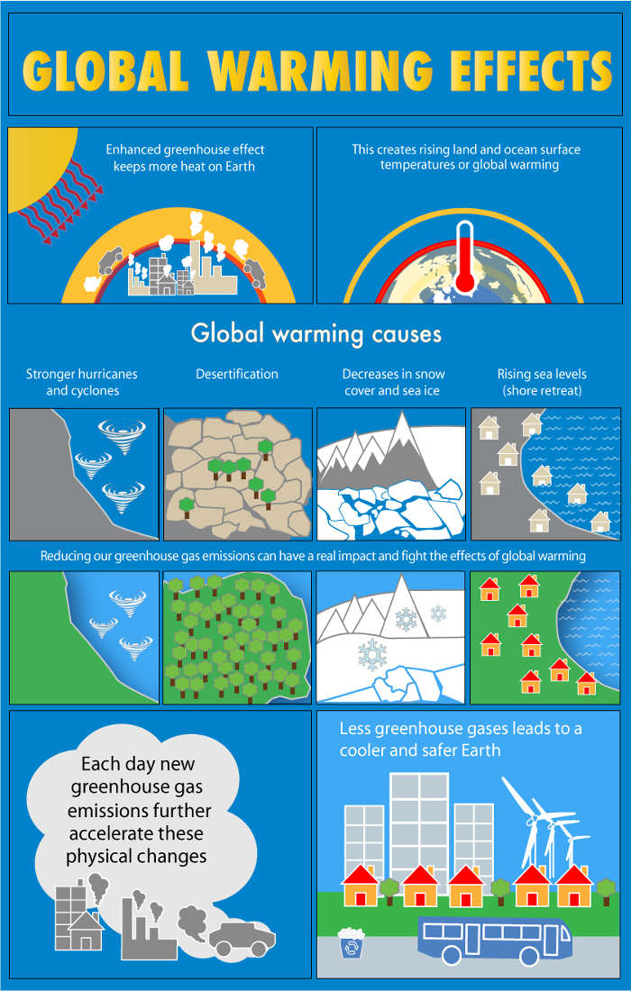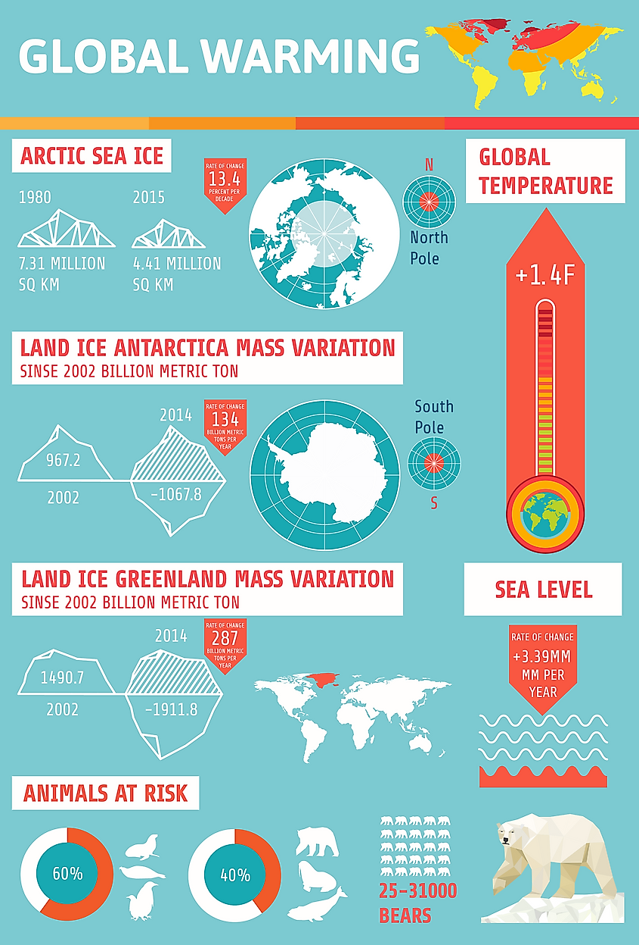
https://www.worldatlas.com/articles/what-are-the-effects-of-melting-glaciers.html
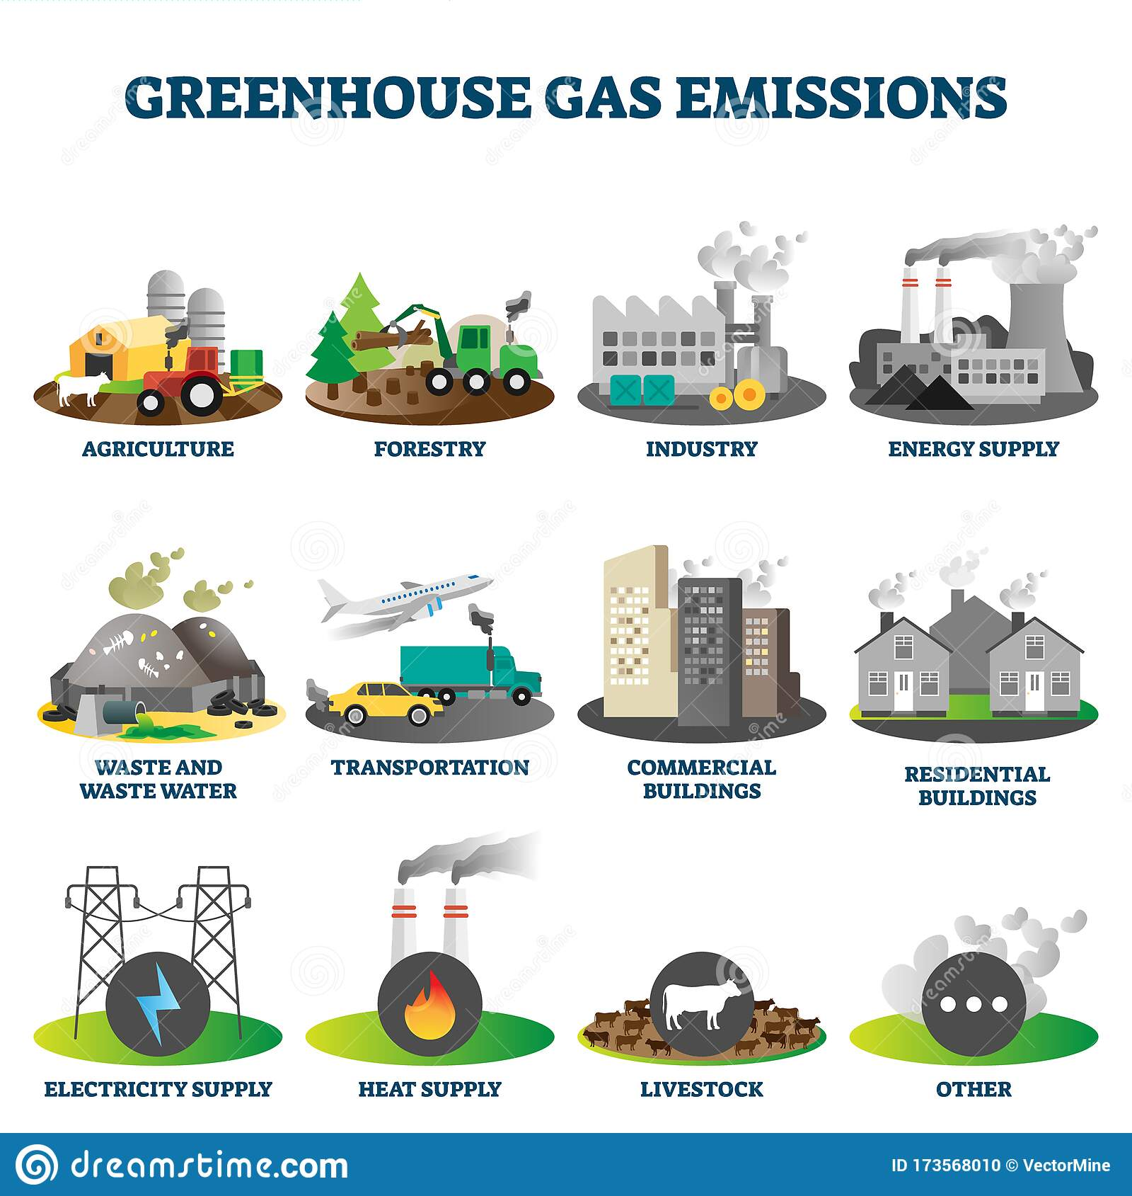

. 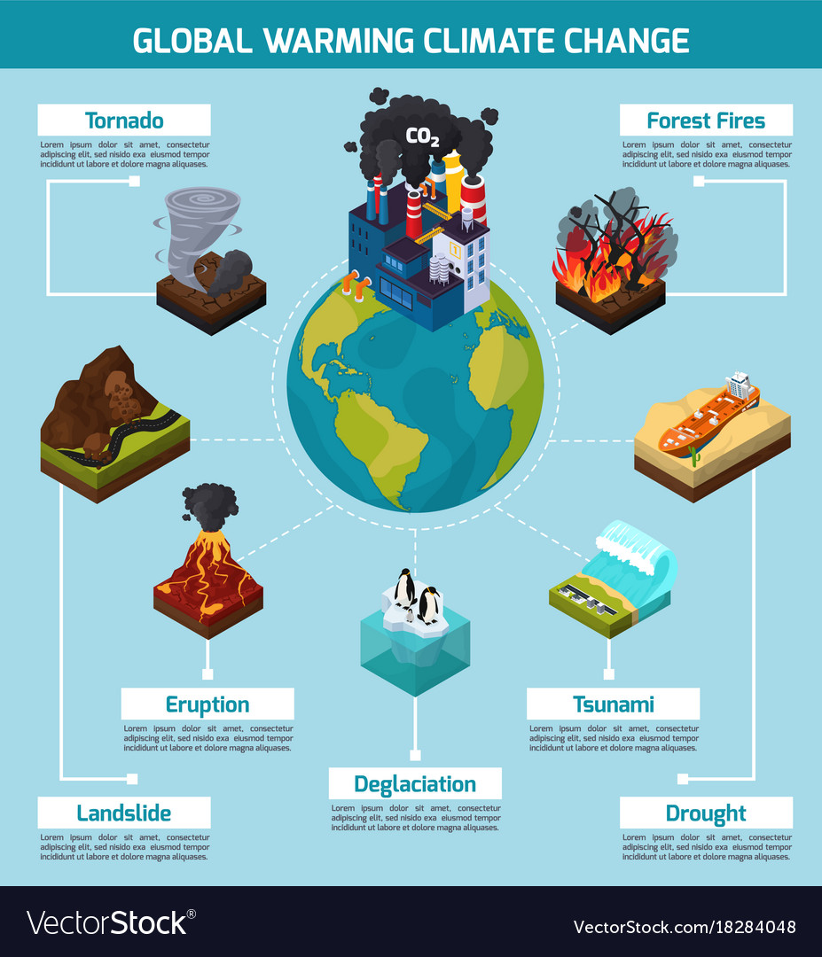

Politics
According to economists like Nicholas Stern, the climate crisis is a result of multiple market failures.
Economists and environmentalists have urged policymakers for years to increase the price of activities that emit greenhouse gases (one of our biggest environmental problems), the lack of which constitutes the largest market failure, for example through carbon taxes, which will stimulate innovations in low-carbon technologies.
To cut emissions quickly and effectively enough, governments must not only massively increase funding for green innovation to bring down the costs of low-carbon energy sources, but they also need to adopt a range of other policies that address each of the other market failures.
A national carbon tax is currently implemented in 27 countries around the world, including various countries in the EU, Canada, Singapore, Japan, Ukraine and Argentina. However, according to the 2019 OECD Tax Energy Use report, current tax structures are not adequately aligned with the pollution profile of energy sources. For example, the OECD suggests that carbon taxes are not harsh enough on coal production, although it has proved to be effective for the electricity industry. A carbon tax has been effectively implemented in Sweden; the carbon tax is USD $127 per tonne and has reduced emissions by 25% since 1995, while its economy has expanded 75% in the same time period.
Further, organisations such as the United Nations are not fit to deal with the climate crisis: it was assembled to prevent another world war and is not fit for purpose. Anyway, members of the UN are not mandated to comply with any suggestions or recommendations made by the organisation. For example, the Paris Agreement, an agreement within the United Nations Framework Convention on Climate Change, says that countries need to reduce greenhouse gas emissions significantly so that global temperature rise is below 2 degrees Celsius by 2100, and ideally under 1.5 degrees. But signing on to it is voluntary, and there are no real repercussions for non-compliance. Further, the issue of equity remains a contentious issue whereby developing countries are allowed to emit more in order to develop to the point where they can develop technologies to emit less, and it allows some countries, such as China, to exploit this.

Food Waste
A third of the food intended for human consumption – around 1.3 billion tons – is wasted or lost. This is enough to feed 3 billion people. Food waste and loss accounts for 4.4 gigatons of greenhouse gas emissions annually; if it was a country, food waste would be the third highest emitter of greenhouse gases, behind China and the US.
Food waste and loss occurs at different stages in developing and developed countries; in developing countries, 40% of food waste occurs at the post-harvest and processing levels, while in developed countries, 40% of food waste occurs at the retail and consumer levels.
At the retail level, a shocking amount of food is wasted because of aesthetic reasons; in fact, in the US, more than 50% of all produce thrown away in the US is done so because it is deemed to be “too ugly” to be sold to consumers- this amounts to about 60 million tons of fruits and vegetables. This leads to food insecurity, another one of the biggest environmental problems on the list.
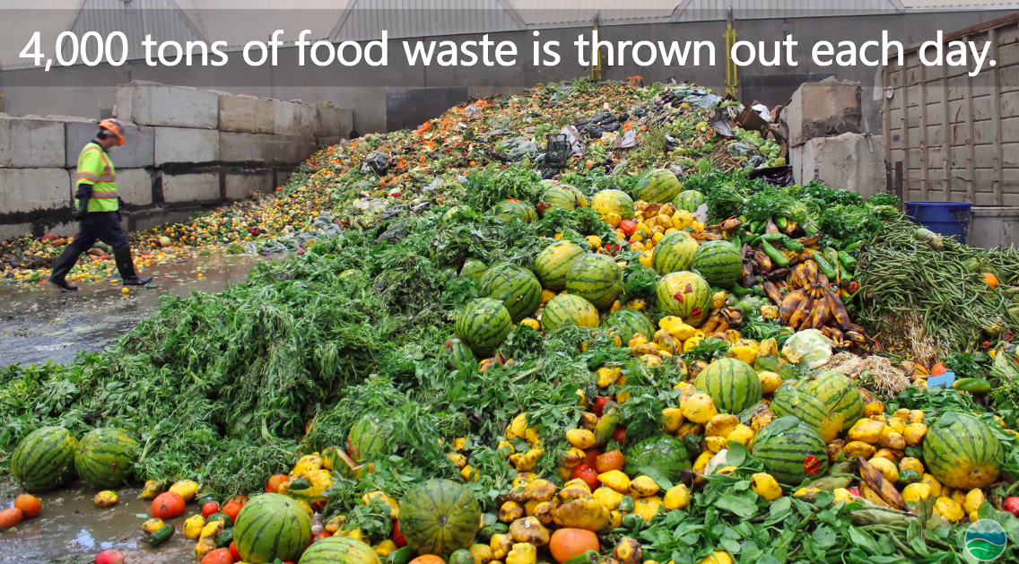
You might also like: 25 Facts About Food Waste

Biodiversity Loss
The past 50 years have seen a rapid growth of human consumption, population, global trade and urbanisation, resulting in humanity using more of the Earth’s resources than it can replenish naturally.
A recent WWF report found that the population sizes of mammals, fish, birds, reptiles and amphibians have experienced a decline of an average of 68% between 1970 and 2016. The report attributes this biodiversity loss to a variety of factors, but mainly land-use change, particularly the conversion of habitats, like forests, grasslands and mangroves, into agricultural systems. Animals such as pangolins, sharks and seahorses are significantly affected by the illegal wildlife trade, and pangolins are critically endangered because of it.
More broadly, a recent analysis has found that the sixth mass extinction of wildlife on Earth is accelerating. More than 500 species of land animals are on the brink of extinction and are likely to be lost within 20 years; the same number were lost over the whole of the last century. The scientists say that without the human destruction of nature, this rate of loss would have taken thousands of years.
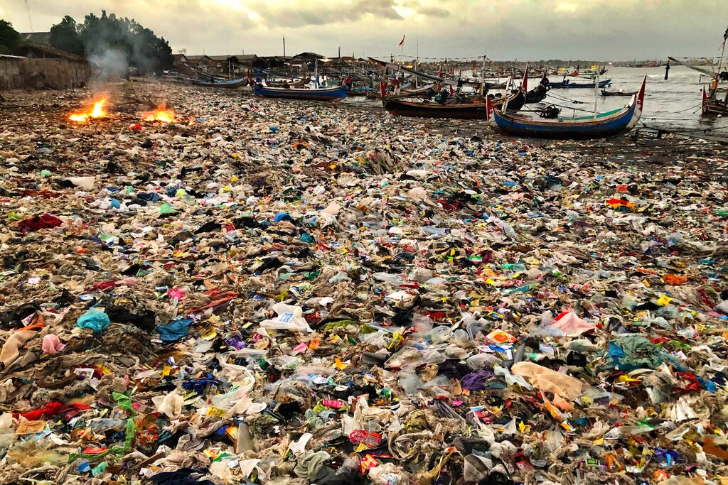Image by: EO Photographer Vincent Kneefel
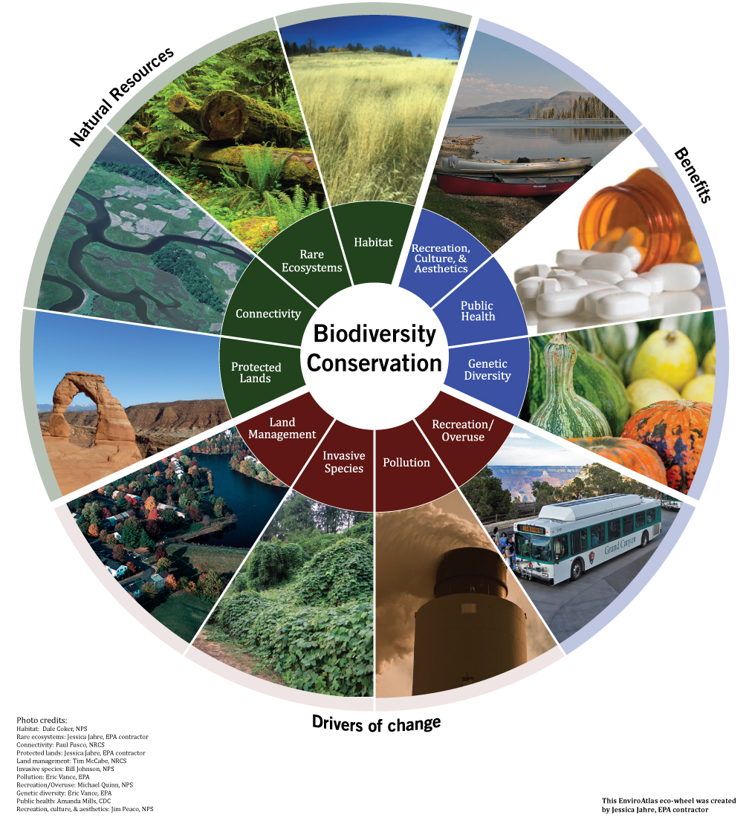

Plastic Pollution
In 1950, the world produced more than 2 million tons of plastic per year. By 2015, this annual production swelled to 419 million tons and exacerbating plastic waste in the environment.
A report by science journal, Nature, determined that currently, roughly 11 million tons of plastic make its way into the oceans every year, harming wildlife habitats and the animals that live in them. The research found that if no action is taken, the plastic crisis will grow to 29 million metric tons per year by 2040. If we include microplastics into this, the cumulative amount of plastic in the ocean could reach 600 million tons by 2040.
Shockingly, National Geographic found that 91% of all plastic that has ever been made is not recycled, representing not only one of the biggest environmental problems of our lifetime, but another massive market failure. Considering that plastic takes 400 years to decompose, it will be many generations until it ceases to exist. There’s no telling what the irreversible effects of plastic pollution will have on the environment in the long run.
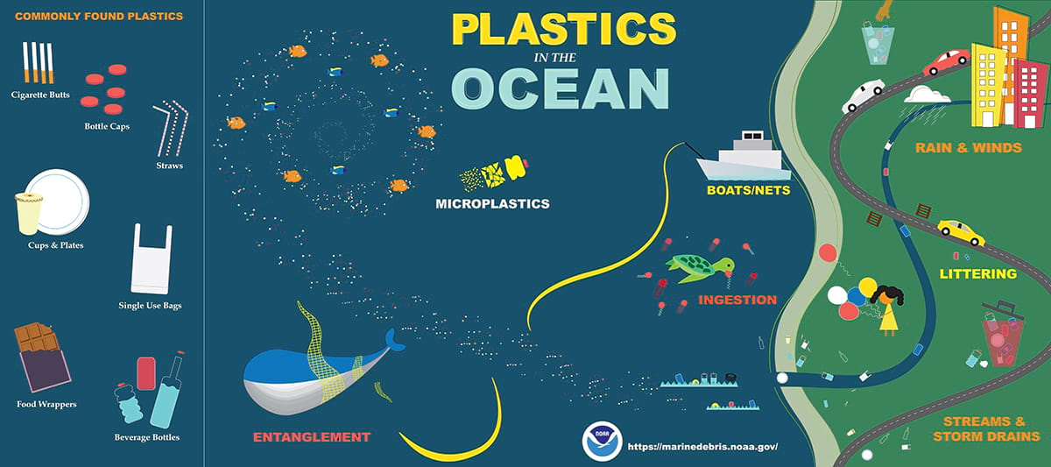
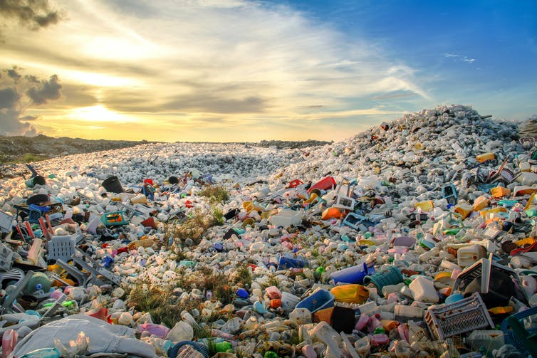

Deforestation
Every minute, forests the size of 20 football fields are cut down. By the year 2030, the planet might have only 10% of its forests; if deforestation isn’t stopped, they could all be gone in less than 100 years.
Agriculture is the leading cause of deforestation, another one of the biggest environmental problems appearing on this list. Land is cleared to raise livestock or to plant other crops that are sold, such as sugar cane and palm oil. Besides for carbon sequestration, forests help to prevent soil erosion, because the tree roots bind the soil and prevent it from washing away, which also prevents landslides.
The three countries experiencing the highest levels of deforestation are Brazil, the Democratic Republic of Congo and Indonesia. However, many countries are tackling deforestation and rebuilding by planting new trees, and are now seeing the lowest rates since the beginning of the century.
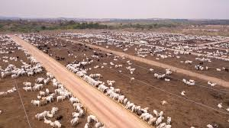
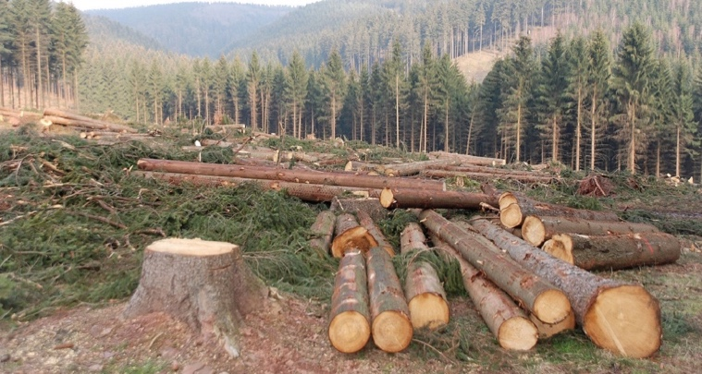
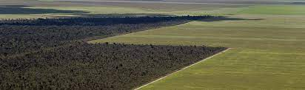
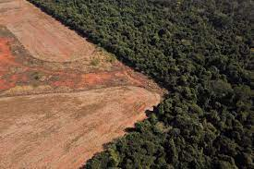

Air Pollution
One of the biggest environmental problems today is outdoor air pollution. Research from the World Health Organization (WHO) shows that an estimated 4.2 to 7 million people die from air pollution worldwide every year and that nine out of 10 people breathe air that contains high levels of pollutants. In Africa, 258 000 people died as a result of outdoor air pollution in 2017, up from 164 000 in 1990, according to UNICEF. Causes of air pollution mostly comes from industrial sources and motor vehicles, as well as emissions from burning biomass and poor air quality due to dust storms.
In Europe, a recent report from the EU’s environment agency showed that air pollution contributed to 400 000 annual deaths in the EU in 2012 (the last year for which data was available).
In the wake of the COVID-19 pandemic, attention has been put on the role that air pollution gases has in transporting the virus molecules. Preliminary studies have identified a positive correlation between COVID-19-related mortalities and air pollution and there is also a plausible association of airborne particles assisting the viral spread. This could have contributed to the high death toll in China, where air quality is notoriously poor, although more definitive studies must be conducted before such a conclusion can be drawn.
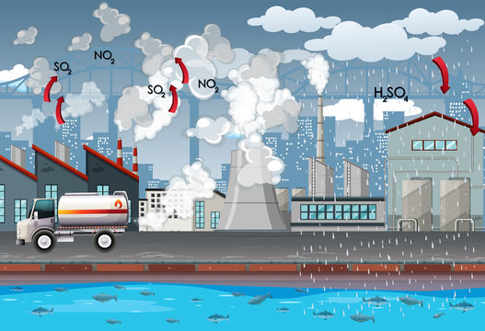

Melting Ice Caps
The climate crisis is warming the Arctic more than twice as fast as anywhere else on the planet. Seas are now rising an average of 3.2 mm per year globally, and are predicted to climb to a total of 0.2 to 2m by 2100. In the Arctic, the Greenland Ice Sheet poses the greatest risk for sea levels because melting land ice is the main cause of rising sea levels.
Representing arguably the biggest of the environmental problems, this is made all the more concerning considering that last year’s summer triggered the loss of 60 billion tons of ice from Greenland, enough to raise global sea levels by 2.2mm in just two months. According to satellite data, the Greenland ice sheet lost a record amount of ice in 2019: an average of a million tons per minute throughout the year, one of the biggest environmental problems that has cascading effects.
If the entire Greenland ice sheet melts, sea level would rise by six metres.
Meanwhile, the Antarctic continent contributes about 1 millimeter per year to sea level rise, which is a third of the annual global increase.
Additionally, the last fully intact ice shelf in Canada in the Arctic recently collapsed, having lost about 80 sq km, or 40%, of its area over a two-day period in late July, according to the Canadian Ice Service.
The sea level rise will have a devastating impact on those living in coastal regions: according to research and advocacy group Climate Central, sea level rise this century could flood coastal areas that are now home to 340 million to 480 million people, forcing them to migrate to safer areas and contributing to overpopulation and strain of resources in the areas they migrate to.
Take Shanghai’s megalopolis for example, which is built around the low-lying Yangtze river delta. As the fourth most populous city in the world, the flood risk in the area is high due to its geographical position. Any flooding caused by a higher rainfall can potentially be catastrophic in relation to evacuation, water management and property damage.
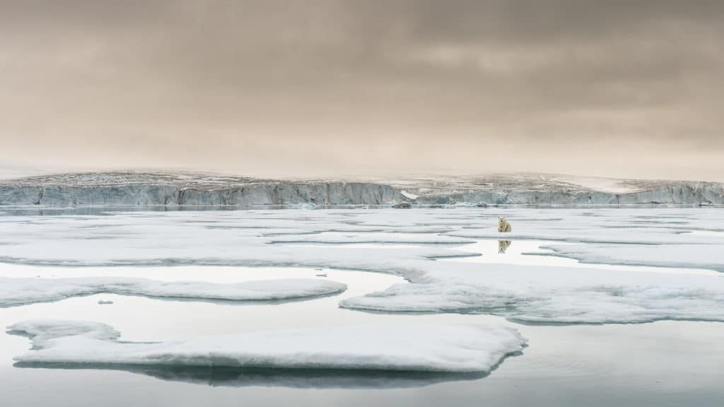
https://www.iberdrola.com/sustainability/melting-glaciers-causes-effects-solutions
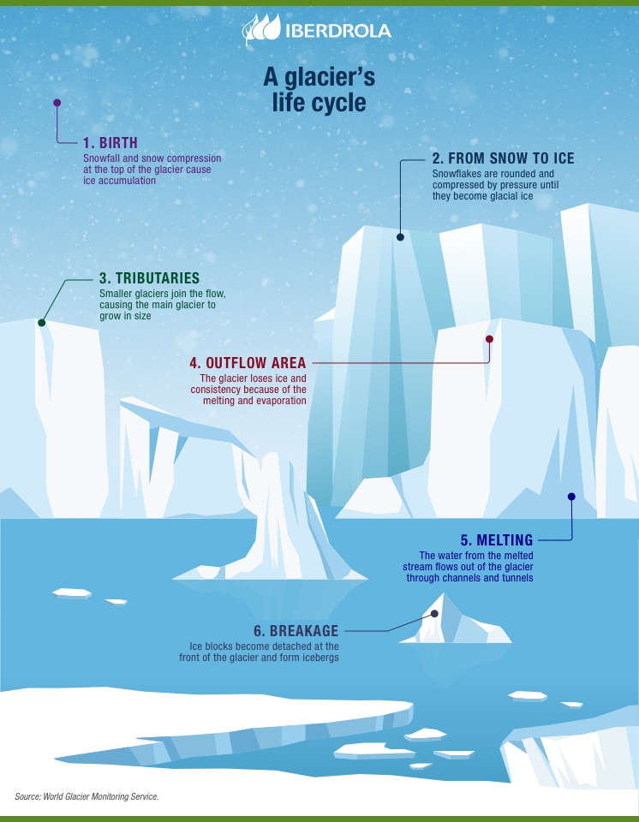

Ocean Acidification
Global temperature rise has not only affected the surface, but it is the main cause of ocean acidification. Our oceans absorb about 30% of carbon dioxide that is released into the Earth’s atmosphere. As higher concentrations of carbon emissions are released thanks to human activities such as burning fossil fuels as well as effects of global climate change such as increased rates of wildfires, so do the amount of carbon dioxide that is absorbed back into the sea.
The smallest change in the pH scale can have a significant impact on the acidity of the ocean. Ocean acidification can have a ripple effect across marine ecosystems and species, its food webs, and provoked changes in habitat quality. Once pH levels reach too low, marine organisms such as oysters, their shells and skeleton could even start to dissolve.
However, one of the biggest environmental problems from ocean acidification is coral bleaching and subsequent coral reef loss. This is a phenomenon that occurs when rising ocean temperatures disrupt the symbiotic relationship between the reefs and algae that lives within it, driving away the algae and causing coral reefs to lose their natural vibrant colours. Some scientists have estimated coral reefs are at risk of being completely wiped by 2050. Higher acidity in the ocean would obstruct coral reef systems’ ability to rebuild their exoskeletons and recover from these coral bleaching events.
Some studies have also found that ocean acidification can be linked as one of the effects of plastic pollution in the ocean. The accumulating bacteria and microorganisms derived from plastic garbage dumped in the ocean to damage marine ecosystems and contribute towards coral bleaching.
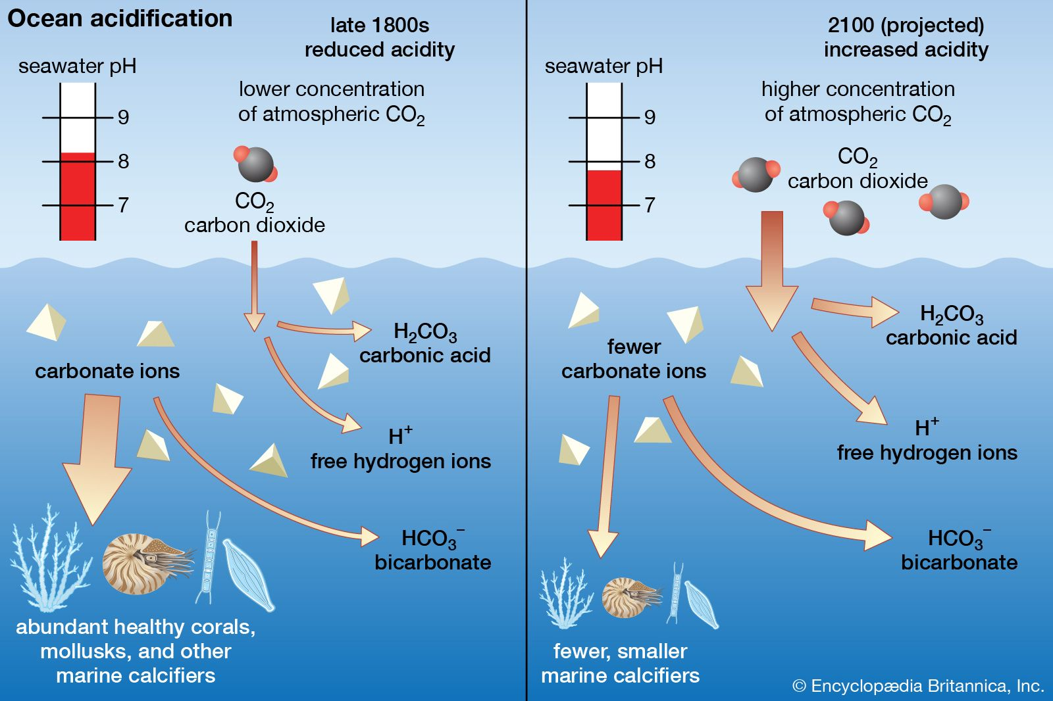
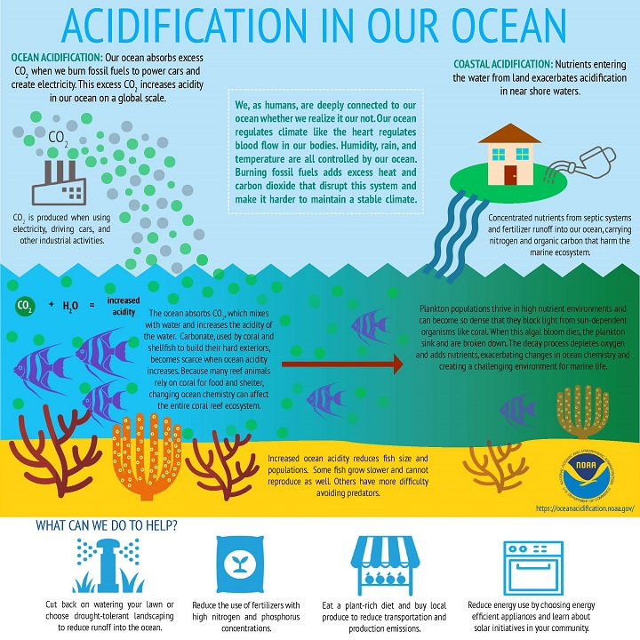
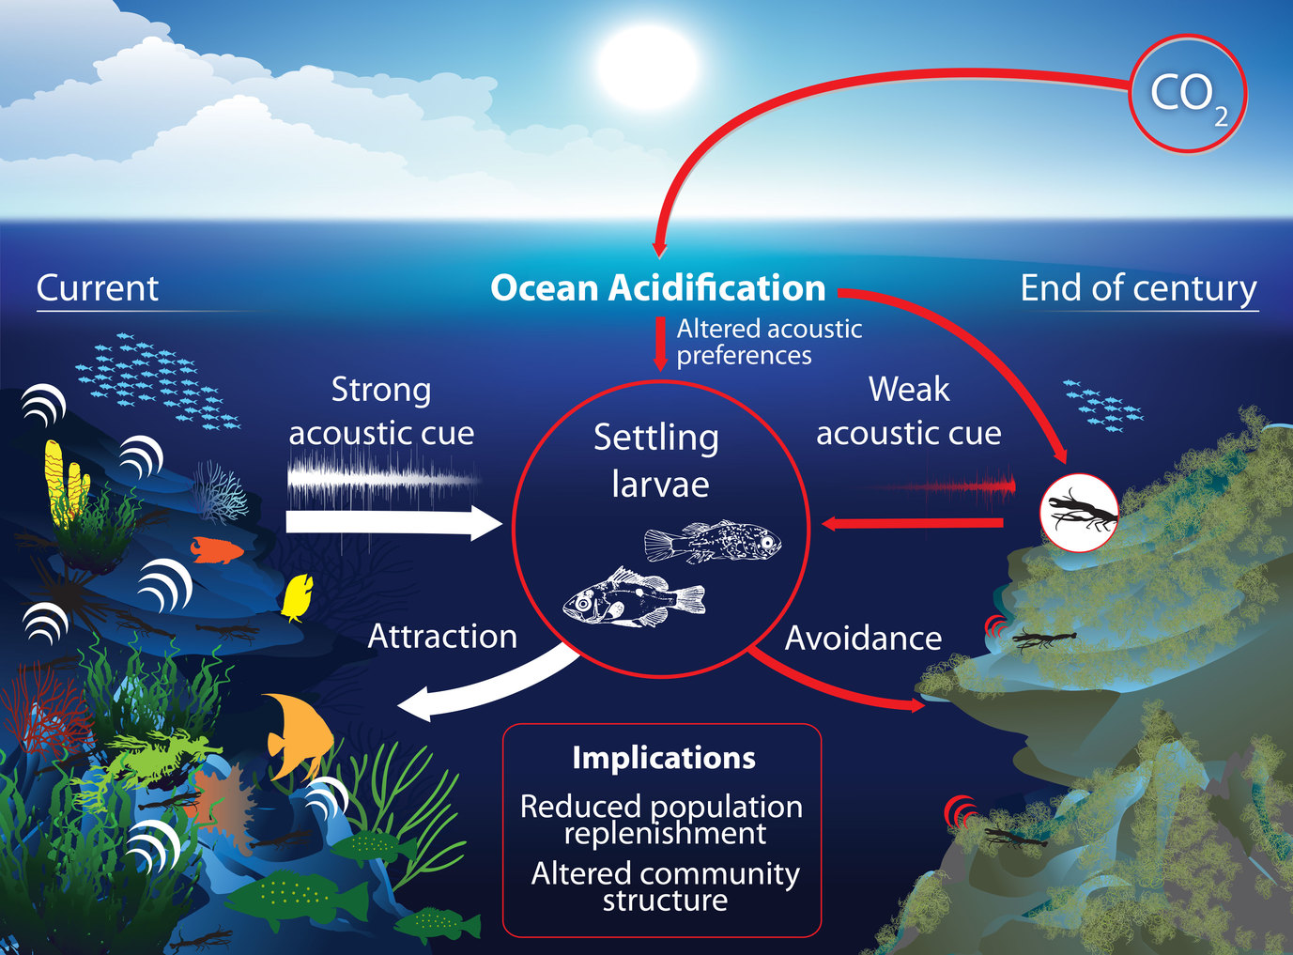
https://news-oceanacidification-icc.org/2016/09/21/the-silencing-of-the-seas-how-our-oceans-are-going-quiet/

Agriculture
Studies have shown that the global food system is responsible for up to one third of all human-caused greenhouse gas emissions, of which 30% comes from livestock and fisheries. Crop production releases greenhouse gases such as nitrous oxide through the use of fertilisers.
60% of the world’s agricultural area is dedicated to cattle ranching, although it only makes up 24% of global meat consumption.
Agriculture not only covers a vast amount of land, but it also consumes a vast amount of freshwater, another one of the biggest environmental problems on this list. While arable lands and grazing pastures cover one-third of Earth’s land surfaces, they consume three-quarters of the world’s limited freshwater resources.
Scientists and environmentalists have continuously warned that we need to rethink our current food system; switching to a more plant-based diet would dramatically reduce the carbon footprint of the conventional agriculture industry.
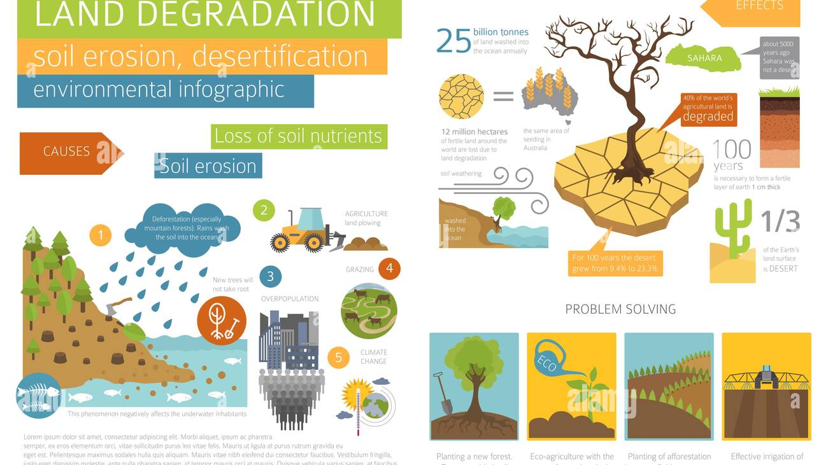
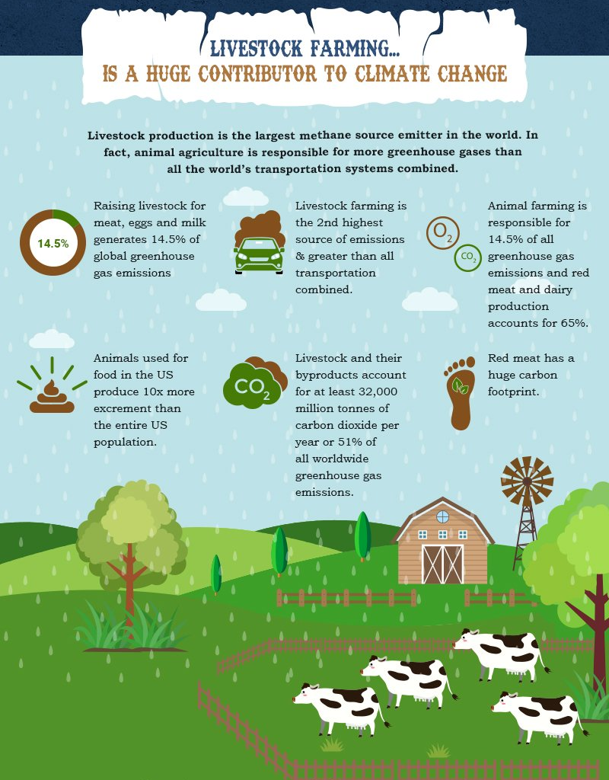

Food and Water Insecurity
Rising temperatures and unsustainable farming practices has resulted in the increasing threat of water and food insecurity and taking the mantle as one of the biggest environmental problems today.
Globally, more than 68 billion tonsof top-soil is eroded every year at a rate 100 times faster than it can naturally be replenished. Laden with biocides and fertiliser, the soil ends up in waterways where it contaminates drinking water and protected areas downstream.
Furthermore, exposed and lifeless soil is more vulnerable to wind and water erosion due to lack of root and mycelium systems that hold it together. A key contributor to soil erosion is over-tilling: although it increases productivity in the short-term by mixing in surface nutrients (e.g. fertiliser), tilling is physically destructive to the soil’s structure and in the long-term leads to soil compaction, loss of fertility and surface crust formation that worsens topsoil erosion.
With the global population expected to reach 9 billion people by mid-century, the Food and Agriculture Organization of the United Nations (FAO) projects that global food demand may increase by 70% by 2050. Around the world, more than 820 million people do not get enough to eat.
The UN secretary-general António Guterres says, “Unless immediate action is taken, it is increasingly clear that there is an impending global food security emergency that could have long term impacts on hundreds of millions of adults and children.” He urged for countries to rethink their food systems and encouraged more sustainable farming practices.
In terms of water security, only 3% of the world’s water is fresh water, and two-thirds of that is tucked away in frozen glaciers or otherwise unavailable for our use. As a result, some 1.1 billion people worldwide lack access to water, and a total of 2.7 billion find water scarce for at least one month of the year. By 2025, two-thirds of the world’s population may face water shortages.
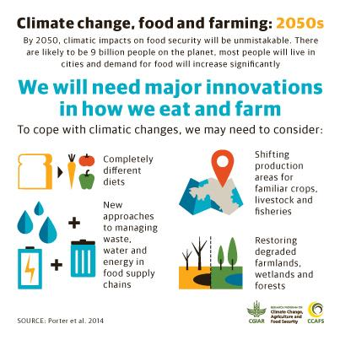
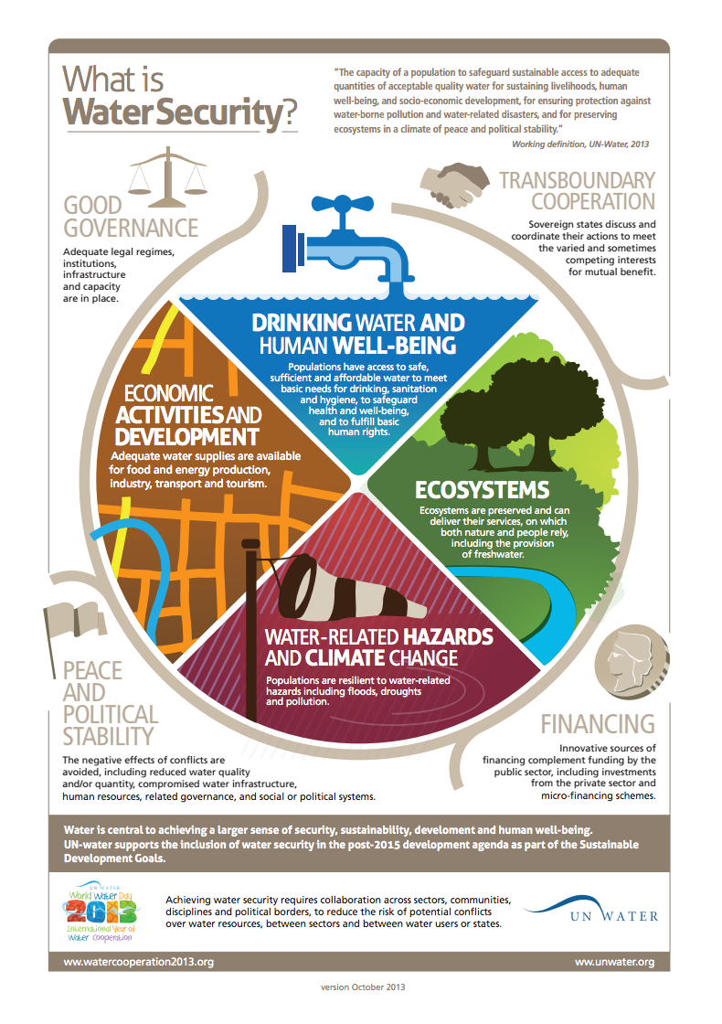

Fashion & Textiles
The global demand for fashion and clothing has risen at a unprecedented rate that the fashion industry now accounts for 10% of global carbon emissions, becoming one of the biggest envrionmetnal problems of our time. Fashion alone produces more greenhouse gas emissions than both the aviation and shipping sectors combined. Also, nearly 20% of global wastewater is a result of textile dyeing, according to the UN Environment Programme.
What’s more, the world at least generated an estimated 92 million tonnes of textiles waste every year and that number is expected to soar up to 134 million tonnes a year by 2030. Discarded clothing and textile waste ends up in landfills, most of which is non-biodegradable, while microplastic from clothing materials such as polyester, nylon, polyamide, acrylic and other synthetic materials, is leeched into soil and nearby water sources. Large amounts of clothing textile are also dumped in less developed countries. (see for more info Chile’s Atacama).
This rapidly growing issue is only exacerbated by the ever-expanding fast fashion business model, in which companies rely on cheap and speedy production of low quality clothing to meet the latest and newest trends. While the United Nations Fashion Industry Charter for Climate Action wants to see fashion and textile companies to commit to achieving net zero emission by 2050, a majority of businesses around the world have yet to address their roles in climate change.
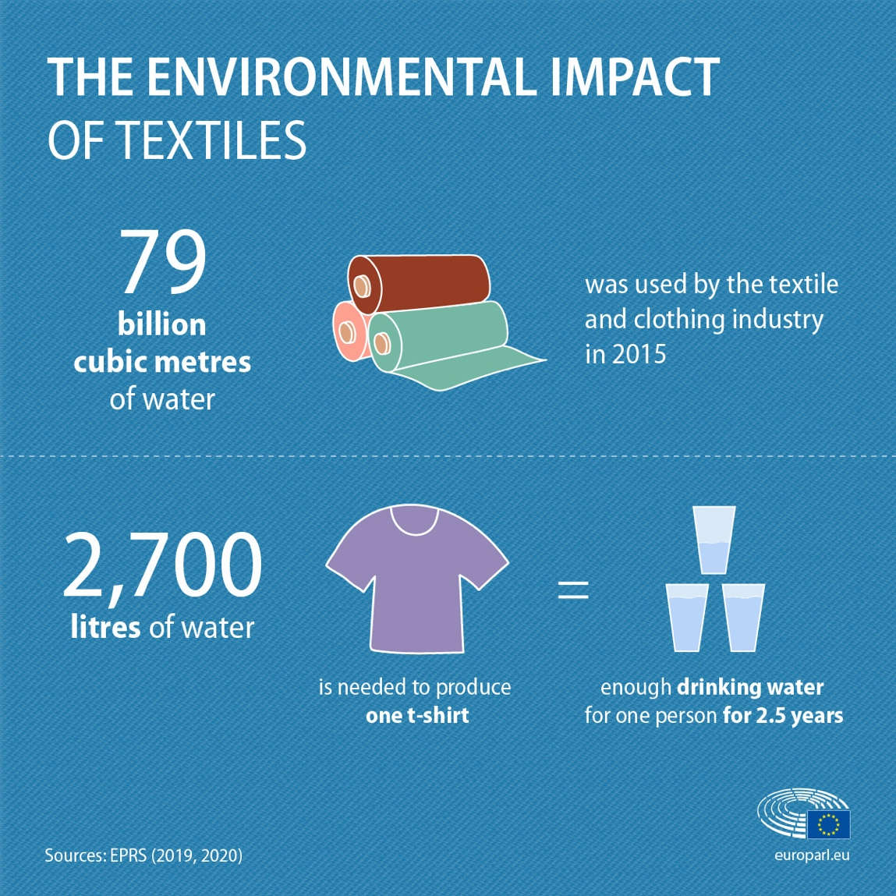

Unit Resources

File library resources with links:

 | Public Link to resources:
Possible Earth Day PowerPoint Slides | https://itss.literacy.io/TeacherLibrary/Files/ViewPublicFile/6292488d-ba68-48aa-a9c1-30b7ad9baeee
Borneo Orangutan’s are in Trouble | Lesson Guide: https://itss.literacy.io/TeacherLibrary/Files/ViewPublicFile/f6ee9e5c-2ae8-4774-8253-c815a09ff95f  Video: https://itss.literacy.io/TeacherLibrary/Files/ViewPublicFile/591d487a-95d7-440d-a233-78c4c56f0088
Comparing Four of Earth’s Biomes | https://itss.literacy.io/TeacherLibrary/Files/ViewPublicFile/f7e6e787-f81c-4999-96d1-e03a0fb2ee05
Dear Mother Earth | https://itss.literacy.io/TeacherLibrary/Files/ViewPublicFile/4b3310c9-1915-49b5-b4d6-118877a93779  https://itss.literacy.io/TeacherLibrary/Files/ViewPublicFile/dafe02f1-300c-422e-a3b8-d368000a267f (Spanish)
Dream Job:Food Rescuer | https://itss.literacy.io/TeacherLibrary/Files/ViewPublicFile/611f7239-2b80-46c9-8f99-39eb8a1ee016 (PDF)  https://itss.literacy.io/TeacherLibrary/Files/ViewPublicFile/c0ceee2f-61dd-4eaf-bbf9-ced77be80b33  https://itss.literacy.io/TeacherLibrary/Files/ViewPublicFile/1ccfefa7-6676-4003-bff8-e13bf834057a (video)  https://itss.literacy.io/TeacherLibrary/Files/ViewPublicFile/dcf16330-a256-4414-aab0-06859ad8d017 (PowerPoint)  https://itss.literacy.io/TeacherLibrary/Files/ViewPublicFile/a8076b6b-2f81-41d0-a9fd-e8153432119b (Spanish)  https://itss.literacy.io/TeacherLibrary/Files/ViewPublicFile/421a1455-7372-4da5-a0c3-9f53d66ffec7 (Spanish PowerPoint)  https://itss.literacy.io/TeacherLibrary/Files/ViewPublicFile/4f3be31f-9c06-4f9d-a6dd-5af9c90efd76 (Spanish video)
Eco-Friendly Food | https://itss.literacy.io/TeacherLibrary/Files/ViewPublicFile/88369281-64d7-4668-bd63-229ea68b5169  https://itss.literacy.io/TeacherLibrary/Files/ViewPublicFile/4ee70baa-0b6e-4c93-8626-de23c643fd48 (Spanish PowerPoint)  https://itss.literacy.io/TeacherLibrary/Files/ViewPublicFile/c8f22a4d-d98c-41a1-ad3c-571153592684 (Spanish)  https://itss.literacy.io/TeacherLibrary/Files/ViewPublicFile/2f079bd1-dbb1-485f-966c-41b604533b52 (English PowerPoint)
Garbage Boats Sweep Rio’s Olympic Bay | https://itss.literacy.io/TeacherLibrary/Files/ViewPublicFile/946b419d-ad73-4dfc-ae3c-206ccdd6b464
Interactions in EcoSystems
Kids Who Make a Difference- Rain Forest Hero | https://itss.literacy.io/TeacherLibrary/Files/ViewPublicFile/9cf2a972-8b1f-4b67-87a6-a1aca4044247
Kids Who Make a Difference: Ryan’s Well- Clean Water for Kids | https://itss.literacy.io/TeacherLibrary/Files/ViewPublicFile/5410e6cc-0b1b-4018-8d3b-0965039bdd79
Lego Gets Serious About Helping the Environment | https://itss.literacy.io/TeacherLibrary/Files/ViewPublicFile/31b9129b-0838-459a-9f59-92a20f9ef9e0  https://itss.literacy.io/TeacherLibrary/Files/ViewPublicFile/7e07f966-3a2d-4993-919a-5c7f259768bb (Spanish)
Living Green | https://itss.literacy.io/TeacherLibrary/Files/ViewPublicFile/87dc3ed7-3442-4f56-a9c4-e1f0c97ecfce  https://itss.literacy.io/TeacherLibrary/Files/ViewPublicFile/0f1b6e2f-9c93-480f-b03d-0a6b38fde49c (PowerPoint)  https://itss.literacy.io/TeacherLibrary/Files/ViewPublicFile/542fb7b0-73da-40ad-b715-9624eca38e29 (Spanish)  https://itss.literacy.io/TeacherLibrary/Files/ViewPublicFile/a7cc3d95-fd03-4526-92ec-200687c5a5eb (Spanish PowerPoint)
Male Sea Turtles Numbers Decline as Earth’s Tempteratures Heat Up | https://itss.literacy.io/TeacherLibrary/Files/ViewPublicFile/f5de3b79-ab51-4af4-83cc-36006f33f6ca  https://itss.literacy.io/TeacherLibrary/Files/ViewPublicFile/b32e6b79-2bd1-429b-8334-30061822993f (PowerPoint)  https://itss.literacy.io/TeacherLibrary/Files/ViewPublicFile/4425fccf-5d7f-49fd-95c0-a235a51a3953 (Spanish)
Monarch Migration Becoming a Dangerous Journey | https://itss.literacy.io/TeacherLibrary/Files/ViewPublicFile/3f5a5273-8c16-4b82-9946-898fa0509115  https://itss.literacy.io/TeacherLibrary/Files/ViewPublicFile/3f5a5273-8c16-4b82-9946-898fa0509115 (Spanish)  https://itss.literacy.io/TeacherLibrary/Files/ViewPublicFile/f8d81311-da90-4a8f-956f-a6c8c193f07c (Spanish PowerPoint)
Natural Resources and You | https://itss.literacy.io/TeacherLibrary/Files/ViewPublicFile/ababf973-4057-441d-897c-b9bb63040ae7
Obama Wants to Help thte Bees by Protecting Where They Live and Eat | https://itss.literacy.io/TeacherLibrary/Files/ViewPublicFile/4dc9c32b-7350-43fc-a63b-1a9060e11aff  https://itss.literacy.io/TeacherLibrary/Files/ViewPublicFile/b920a28c-dc2f-45d3-9462-5bb6eb46b4f5 (Spanish)
One Plastic Bag | https://itss.literacy.io/TeacherLibrary/Files/ViewPublicFile/c0dde7ba-8a00-4726-beb0-5d3c22f220b0  https://itss.literacy.io/TeacherLibrary/Files/ViewPublicFile/c0dde7ba-8a00-4726-beb0-5d3c22f220b0 (PowerPoint)  https://itss.literacy.io/TeacherLibrary/Files/ViewPublicFile/26044816-8602-4e33-98dc-6203062d50ce (Spanish)  https://itss.literacy.io/TeacherLibrary/Files/ViewPublicFile/09e5449d-673f-4492-98df-ca69eb9720f8 (Spanish PowerPoint)
Potatoes on Rooftops | https://itss.literacy.io/TeacherLibrary/Files/ViewPublicFile/64bebbaf-19c3-4693-959b-2e1dadecb46b  https://itss.literacy.io/TeacherLibrary/Files/ViewPublicFile/c2ed6525-53f7-4ae9-942e-4ebec904731a (PowerPoint)  https://itss.literacy.io/TeacherLibrary/Files/ViewPublicFile/13694ed5-4e74-41a7-a26e-4c408d4aa0b1 (Spanish)  https://itss.literacy.io/TeacherLibrary/Files/ViewPublicFile/5acb72aa-7207-4984-b701-d759a06f3d44 (Spanish PowerPoint)
Sarah Cynthia Stout Would Not Take the Garbage Out | https://itss.literacy.io/TeacherLibrary/Files/ViewPublicFile/b5bebae8-7601-4deb-b428-3b64e755b622
Seeds of Change | https://itss.literacy.io/TeacherLibrary/Files/ViewPublicFile/5855bd84-9f32-466a-b618-b526bb972f11  https://itss.literacy.io/TeacherLibrary/Files/ViewPublicFile/f89eef45-7098-4b9d-b355-4c0240d240bc (PowerPoint)  https://itss.literacy.io/TeacherLibrary/Files/ViewPublicFile/560aa2be-bdfa-4b34-bd92-944db64d5602 (Spanish)  https://itss.literacy.io/TeacherLibrary/Files/ViewPublicFile/ca1f042e-3a63-4718-b9b7-82ec5d0bdaf6 (Spanish PowerPoint)
Should Communities Limit the Use of Plastic Bags? | https://itss.literacy.io/TeacherLibrary/Files/ViewPublicFile/a88461a9-31d2-4188-b507-53eef8a5a28c  https://itss.literacy.io/TeacherLibrary/Files/ViewPublicFile/90467fb7-e66b-4bbd-9dab-5cc15696a33d (Spanish)
Solution of Sewage into Drinking Water Gains Appeal as Drought Continues | https://itss.literacy.io/TeacherLibrary/Files/ViewPublicFile/d6ead3f8-cb13-4a2b-9943-e0f755466c83  https://itss.literacy.io/TeacherLibrary/Files/ViewPublicFile/428c6061-4037-47c7-8c4a-93eec4384956 (Spanish)
Student Water Conservation Project Brings Bill to State Legislature | https://itss.literacy.io/TeacherLibrary/Files/ViewPublicFile/a067e0ca-927b-4d95-8ab9-3a5b4ea9a649  https://itss.literacy.io/TeacherLibrary/Files/ViewPublicFile/8b21cdc9-fea4-4758-992c-73fc30cd41cf (Spanish)
The Good Garden | https://itss.literacy.io/TeacherLibrary/Files/ViewPublicFile/f27a36e9-7a45-48bb-a9bb-01da37cbe628  https://itss.literacy.io/TeacherLibrary/Files/ViewPublicFile/044bd6a7-b3be-464b-8cfa-0e9f4db92778 (PowerPoint)  https://itss.literacy.io/TeacherLibrary/Files/ViewPublicFile/4e83c90d-2326-4f46-b658-00d9ea353e01 (Spanish)  https://itss.literacy.io/TeacherLibrary/Files/ViewPublicFile/99254e3f-52ff-4e4f-8cb3-15df6d977a08 (Spanish PowerPoint)
The Protective Power of Nature Preserves | https://itss.literacy.io/TeacherLibrary/Files/ViewPublicFile/7181a07f-0ce4-46cc-a993-02b2274b9ac9  https://itss.literacy.io/TeacherLibrary/Files/ViewPublicFile/34790918-0e33-4b89-b418-3ad02065af41 (PowerPoint)  https://itss.literacy.io/TeacherLibrary/Files/ViewPublicFile/ceb8653b-a69d-42d8-be6e-f93b9f232c94 (Spanish)  https://itss.literacy.io/TeacherLibrary/Files/ViewPublicFile/dca71aab-4b25-499f-b3ad-856431996ef3 (Spanish PowerPoint)
Environmental Systems Unit | https://itss.literacy.io/TeacherLibrary/Files/ViewPublicFile/fb195ed9-dd5e-45b7-b3df-69dff1815582
One Little Can: How one girl’s actions set off a series of changes in her community | https://itss.literacy.io/TeacherLibrary/Files/ViewPublicFile/71ecbc7e-4b05-46f7-b60a-98e0e65cb59b
Kids Fight Climate Change | https://itss.literacy.io/TeacherLibrary/Files/ViewPublicFile/22a3fb56-e6f1-40aa-bd38-ee0c8368d06a
 | https://itss.literacy.io/TeacherLibrary/Files/ViewPublicFile/0fec7b2b-c9eb-4e02-9dc6-85d46868cb22
The Lorax | Guide: https://itss.literacy.io/TeacherLibrary/Files/ViewPublicFile/b9ef7956-534d-4e1f-b16d-7d3837f96153  Powerpoint:  https://itss.literacy.io/TeacherLibrary/Files/ViewPublicFile/6b9c22e0-c0ea-4552-b5b2-6d03b77cbf7b  Spanish:  https://itss.literacy.io/TeacherLibrary/Files/ViewPublicFile/3c82c2c0-981a-440f-ab02-17db7727cd07

Vocabulary:
Word | Example sentence | Meaning
acid rain noun | Burning fossil fuels in one country can cause acid rain in other countries. | rain that contains harmful chemicals that collect in the atmosphere when fossil fuels are burned
ban verb | Our school has banned plastic bottles because they're so bad for the environment. | to not allow something (eg. smoking, alcohol, plastic bags, protest marches, etc.)
carbon dioxide (CO2) noun | Trees and plants absorb carbon dioxide and release oxygen into the air. | a gas that's released when carbon is burned (for example coal or oil), or when people or animals breathe out
carbon footprint noun | Travelling by air, driving a car or using coal-generated electricity will make your carbon footprint bigger. | a measurement of the amount of carbon-dioxide a person adds to the atmosphere
carcinogen noun | Cigarette smoke contains a number of carcinogens. | a substance that has been linked to causing one or more types of cancer
carpool verb | I carpool to work with two of my neighbours who also work downtown. | to share a car instead of driving one alone
clear-cut verb | Forests never recover fully after being clear-cut. | to destroy a forest by cutting down all the trees
clearcutting (also clearfelling) noun | Did you know that clearcutting is the worst way to use a forest's resources? | a forestry or logging practice in which most or all trees in an area are cut down
climate change noun | Do you really think you know more about climate change than a real climate scientist? | global changes in temperature, wind patterns, rainfall, etc. mainly caused by the burning of fossil fuels like coal and oil
compost verb | Since we started composting we've reduced our garbage by half. | to put organic waste like vegetable peels, uneaten food, grass clippings and leaves into a large container that breaks it down into healthy soil
commute verb | Imagine how much pollution you cause by commuting by car for two hours a day? | to travel from home to work and back
conservation noun | Conservation wasn't a big issue until the book Silent Spring was published in 1966. | the protection and preservation of natural environments and resources
consume verb | Americans consume more than their share of the earth's resources. | to use things like energy, fuel, materials, food, water, etc.
contaminated adj. | Their contaminated milk powder made lots of babies really sick. | carrying harmful bacteria or toxins that can cause disease or death
developing country noun | We moved our factory to a developing country because of cheap labour and weak environmental laws. | a poor nation that's gradually becoming richer and more advanced
domestic waste (also household waste) noun | How much domestic waste does your family produce every day? | rubbish or garbage from a house or apartment
donate verb | If you donate money to Greenpeace, you'll be helping endangered animals. | to give money or goods to an organization you want to help or support
dump verb | You can be sent to jail for dumping hazardous waste, you know. | to put waste in the wrong place (eg. put toxic waste into a river)
eco-community or ecovillage noun | Our kids want to live in that eco-community near the forest. | a community with environmentally-friendly buildings, clean technology and renewable energy like solar and wind
endangered species noun | Every year more animals are listed as endangered species. | animals or plants in danger of becoming extinct or disappearing in the near future
energy-efficient adj. | Those energy-efficient light bulbs are much cheaper these days. | able to use less energy (esp. of vehicles, appliances, buildings, etc.)
environmentalist noun | Fossil fuel companies have tried to damage the image of environmentalists and climate scientists. | a person who protects the natural world and educates others about environmental problems
ecosystem noun | All those plants, insects and birds in your garden are part of an ecosystem. | the complex system of relationships between living things and their environment
emit verb | Cars emit harmful pollutants into the atmosphere. | to release or project something (eg. light, sound, smoke, gas, radiation, etc.)
extinct adj. | Lots of Australian animals have become extinct since the British took control. | no longer existing or lost forever (of an animal, bird or plant species)
fertilize verb | If you are going to fertilize your lawn, make sure to use an organic fertilizer. | to add chemicals or organic material to soil so that plants grow better
food chain noun | We need to know where each species fits in the food chain. | the order in which organisms in an ecosystem eat one another
fossil fuel noun | Burning fossil fuels is a major cause of global warming. | a fuel like oil or coal formed from very old plant and animal fossils
global warming (also climate change) noun | Rising sea levels, melting ice caps and coral reef bleaching are caused by global warming. | higher air and sea temperatures partly caused by man-made increases in greenhouse-gas levels
green adj. | If you want to save the planet, join one of the green political parties. | concerned with protecting the natural environment and the planet
greenhouse gas noun | The more greenhouse gases we produce, the worse climate change will get. | a gas in the atmosphere that stops heat from escaping into space
habitat noun | Lots of animals will become extinct if their natural habitats are destroyed. | the place in which a species normally lives
hazardous waste noun | They increased their profits by dumping hazardous waste into the ocean. | dangerous substances that need careful disposal (eg. toxic or nuclear waste)
minimize verb | Taking public transport instead of driving a car minimizes your impact on the environment. | to reduce as much as possible
pesticide noun | Can't we find a pesticide that's safe? | a chemical that's sprayed on crops to stop insects from destroying them
pollutant noun | The Environmental Protection Agency checks levels of pollutants. | a substance or material that damages the natural environment
pollute verb | Fumes from factories pollute our air. | to release waste substances into the air, water and soil
pollution noun | All the pollution around here comes from factories and mines. | the contamination of the environment, esp. by industrial waste products and chemicals like pesticides
preserve verb | We need stronger laws in order to preserve our forests. | to keep something in its original state
protect verb | It's really important to protect our water supply. | to keep from harm
protest verb | Environmentalists will protest if the loggers try to destroy the forest. | to show you disagree with something, esp. as part of a group of protesters
recycle verb | The green bin's for things that can be recycled like paper and glass. | to make something new from materials that have been used before
reduce verb | You can reduce your household waste by buying products with less packaging. | to use less or make something smaller
reforestation noun | Plant twenty trees in our reforestation project and you'll get into our dance party for free! | the planting of trees and plants to help a damaged or destroyed forest recover
renewable adj. | We're producing cheaper renewable energy these days. | can be used without running out, esp. of energy sources like solar and wind
renewables noun | If you want to make money, invest in renewables. | forms of energy that can be replaced naturally, such as hydro-electricity, solar energy and wind power
rely on verb | We won't have to rely on power companies if we use solar and wind power instead. | to depend on (or need) someone or something
reuse verb | We try to reuse things like plastic bags and bottles. | to use again
self-sufficient adj. | We're going to live in a self-sufficient farming community. | able to function, or produce all that's needed, without outside help
smog noun | The smog was so bad that we had to wear air-filter masks. | a thick dirty cloud at ground level caused by pollutants reacting to sunlight
throw away verb | Don't throw away your grass clippings; leave them on your lawn. | to get rid of something you don't want
toxic adj. | After the mine released toxic waste into the river, all the fish died. | deadly or poisonous (of waste, chemicals, pollutants, etc.)
toxin (toxic chemical) noun | Smoke from factories often contains dangerous toxins. | a poisonous substance that damages health or the environment
use up verb | We are using up the earth's natural resources faster than ever. | to use something until there's none left
waste verb | Don't waste toilet paper; use one or two sheets instead of three or four. | to use more than necessary, or to use inefficiently
wildlife noun | I love taking pictures of wildlife in the forest. | animals, birds, insects, etc. living naturally in the wild
zero-emission adj. | Zero-emission vehicles like electric cars are much cheaper now. | releasing no greenhouse gases like carbon-dioxide or methane

Other Resources

- Project Learning Tree has compiled K-8 Resources, activities, and live links to copyright free resources on Teaching About Climate Change
https://www.plt.org/wp-content/uploads/sites/5/2022/01/PLT-WET-WILD-Teaching-about-Climate-Change-Guide.pdf

- Poems: https://www.poetryfoundation.org/collections/146462/poetry-and-the-environment

Book ideas w/o a KAT guide:

What a Waste: Trash, Recycling, and Protecting our Planet by Jess French
https://www.youtube.com/watch?v=Y18sB-oBsbU&t=32s

Earth Book by Todd Parr
https://www.youtube.com/watch?v=lpEc5nHqO2c

A Planet full of Plastic and How You can Help by Neal Layton
https://www.youtube.com/watch?v=imZ37JldXro

The boy Who Grew a Forest by Sophia Gholz
https://www.youtube.com/watch?v=D_KO1dl5Y3E

I Can Save The Earth by Litte Green Books
https://www.youtube.com/watch?v=Y18sB-oBsbU&t=32s

Why Should I Recycle by Mike Gordon
https://www.youtube.com/watch?v=vaHmtCA_BjM

The Mess That We Made
https://www.youtube.com/watch?v=5xeGc9ADp_U

It’s Earth Day by Mercer Mayer
https://www.youtube.com/watch?v=_GqM-U5dCsQ

Earth Day Every Day by Lisa Bullard
https://www.youtube.com/watch?v=qvdhsn-BFDI

Michael Recycle by Ellie Bethel
https://www.youtube.com/watch?v=pJweMxEhjlU

