Big Questions: Do rubber tires insulate cars from lightning?
By How Stuff Works, adapted by Newsela staff on 09.12.19 Word Count 403
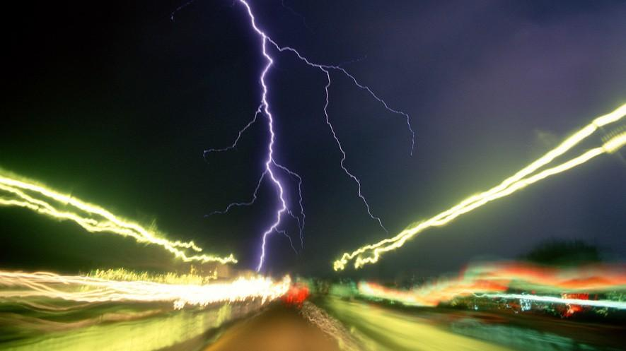
Level 850L
Lightning strikes during a nighttime storm on an interstate highway in Tucson, Arizona. Passing cars create light trails in the rainy night. Photo by: Wild Horizons/Universal Images Group via Getty Images

You don't want to find yourself sitting in traffic during certain kinds of weather. Hurricanes and tornadoes come to mind, of course. Any storm that can blow your car away is going to cause a
scary, unsafe situation. But for years, we've heard that during thunderstorms, there's no safer place than inside your car.
Supposedly, being in a car is your best bet to protect you from lightning, because rubber is an insulator of electricity. In other words, electricity cannot flow through rubber. Therefore, the rubber tires of a car will keep you safe and sound inside your vehicle. The same reasoning is
behind the idea that you should wear rubber-soled shoes in thunderstorms. No harm comes to a person wearing rubber shoes. That's what Grandma always said, anyway.
Unfortunately, these assumptions are not quite correct. Rubber does not protect you from lightning. Rubber is indeed an electrical insulator, but the rubber of your shoes or tires are way too
thin to protect you from a lightning strike. Your grandmother is partly right, though. Your car is a fairly safe place to be in a thunderstorm, but for a different reason entirely.
The Car's Metal Frame May Protect You

The rubber from the tires won't protect you from lightning. However, the metal frame of the car certainly could. Electricity takes the path of least resistance. It flows where it is least blocked,
which is down the metal framework of your car. A metal frame conducts, or carries, an electric charge to the ground, leaving the inside shock-free. So, by remaining in your car, you're completely safe from any lightning that might strike — right?
Not so fast. First, you need to have an enclosed metal-framed car for this to work. That means convertibles with pull-down roofs or fiberglass-framed cars are zero help in a storm. Further, even if you do have a metal-framed car, you won't necessarily escape injury. There are all kinds of metal things inside the car, such as door handles, radio dials and even the steering wheel. If you touch any of them, they will conduct the lightning your way.
What, then, is your best bet if you're in a car during a storm? The driver should pull over, turn off the engine and turn on the emergency lights. Then everyone in the car should sit quietly with their hands to themselves until the storm passes. Grandma would approve.

TEXT STRUCTURE LESSON GUIDE©
This page must be completed for every text students read
Story/Article/Chapter: Story/Article/Chapter: Big Questions: Do rubber tires insulate cars from lightning?

TEK 5.6B-Demonstrate that the flow of electricity in circuits requires a complete path through which an electric current can pass and can produce light, heat, and sound.
TEK 4.6-The student knows that energy exists in many forms and can be observed in cycles, patterns, and systems.
TEK 4.6B-Differentiate between conductors and insulators of thermal and electrical energy.
TEK4.6C-Demonstrate that electricity travels in a closed path, creating an electrical circuit.

Text Structure(s): {Please choose cause and effect, problem and solution, and/or comparison text structure to organize the lesson.}

Overall: Cause, Problem and Solution
Paragraph 4: Cause and Effect

Introduction to selection: {Make sure to introduce the text structure as you introduce the selection}

Today we are going to

Signaling Words in Passage:  cause, situation, protect, takes the path, leaving | CHECKPOINT #1  Vocabulary Words: {Identify words your students would not understand}  insulate (insulator), conduct (conductor), resistance, fiberglass
CHECKPOINT# 2
Overall Main/Key Idea for whole selection:
{Make sure to use the text structure specific main idea stem that matches the overall text structure for the passage. For example, for cause and effect use: The cause is _____ and the effect is ______.}

The cause is lightning in a thunderstorm. The problem is we think that rubber keeps us safe. The solution is the car’s metal frame.

Main/Key Idea for paragraph 4 :

The cause is the car’s frame is made of metal. The effect is the lightning is attracted to the metal.

CHECKPOINT #3
Inference Questions: {Use the STAAR sample question stems if needed}

- The information that electricity takes the path of least resistance, down the metal framework of the car, is important to the selection because-
- If rubber is an insulator that electricity cannot flow through, what can you infer would be good uses for rubber?
- Based on the information in paragraphs 4 & 5, how would fiberglass be classified; conductor or insulator?
STAAR Practice Questions:

1. The table lists some physical properties of two objects.

Object 1 | Object 2
Solid | Solid
Insulates Thermal Energy | Conducts Thermal Energy
Less dense than water | More dense than water
Poor electrical conductor | Good electrical conductor

Based on their properties, which of the objects is most likely a metal?

A. Object 1, because it is a solid that is less dense than water.

B. Object 2, because all metals float in water.

C. Object 2, because metals conduct thermal energy and electricity.

D. Object 1, because it can be used to provide insulation for thermal energy.

2. The circuit below does not work.

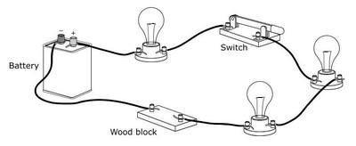

Which procedure would most likely allow the bulbs to light?

A. Open the switch and then connect the two wires that are attached to the wood block.

B. Switch the positions of the two wires that are connected to the battery and then open the switch.

C. Move the switch closer in the circuit to the battery.

D. Connect the two wires that are attached to the wood block.

Summary for the whole selection: {Make sure to extend the main idea written on page 1 and include details supporting each part e.g., cause, problem, and solution}

The cause is lightning in a thunderstorm. Lightning is a form of electricity and could strike us. The problem is we think that rubber keeps us safe. The rubber on your tires or the soles of your shoes is way too thin to protect you from a lightning strike. The solution is the car’s metal frame. Electricity flows where it is least blocked, which is down the metal framework of your car. A metal frame conducts, or carries, an electric charge to the ground, leaving the inside shock-free.

Summary Multiple Choice Question Practice: {Create a multiple-choice question asking students to select the best summary}
What is the best summary for the selection?
- Lightning is a form of electricity and can strike you. Being in your car is your best bet to protect you from lighting because the rubber is an insulator of electricity.
- Electricity takes the path of least resistance. It flows where it is least blocked, which is down the metal framework of your car. A metal frame conducts, or carries, an electric charge to the ground, leaving the inside shock-free.
- Lightning in a thunderstorm can be dangerous. Lightning is a form of electricity and could strike us. We think that rubber keeps us safe. The rubber on your tires or the soles of your shoes is way too thin to protect you from a lightning strike. The car’s metal frame conducts or carries an electric charge to the ground, leaving the inside shock-free.
- Sitting in traffic during bad weather is a safe place to be if your car has a fiberglass frame and rubber tires. Rubber is an insulator of electricity and will protect you from lightning and the fiberglass frame will attract the lightning and carry it to the ground.

Summary for paragraph 4: {Make sure to extend the main idea written on page 1 and include details supporting each part e.g., cause, effect}

The cause is the car’s frame is made of metal. Metal conducts electricity. The effect is the lightning is attracted to the metal frame. The metal carries an electric charge from the lightning strike to the ground, leaving the inside shock-free.

This lesson planning page is part of three grant funded projects led by Dr. K. Wijekumar at Texas A&M University. The materials are designed to improve reading comprehension and to be used with the text structure strategy instruction in language arts, science, social studies, special education, and bilingual classrooms. Most importantly, this planning page ensures consistency of instruction horizontally and vertically aligned and overcomes contradicting instruction in textbooks.

