Magnets and magnetism
By Encyclopaedia Britannica, adapted by Newsela staff on 08.21.19
Word Count 529
Level 560L
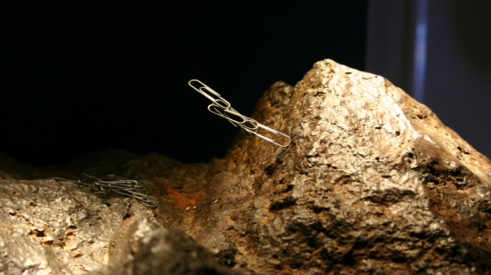Image 1. Metal paperclips stick to a lodestone rock. Lodestone is a natural magnet. Photo by: Ryan Somma/Flickr
A magnet is a rock or a piece of metal. It can pull certain types of metal toward itself. The force of magnets is called magnetism. It is one of the main forces of nature.
Magnetism works over a distance. A magnet does not have to be touching an object to pull it. What Causes Magnetism?
Magnets exist in nature. Certain rocks are magnets. One type of magnetic rock is lodestone.
Magnetism is caused by tiny particles called electrons. Everything in the world is made up of units called atoms. Atoms are made up of electrons and other particles. The electrons spin around the atom's center. This is called the nucleus. The spinning electrons form tiny magnetic forces. Sometimes, many of the electrons spin in the same direction. Then all the tiny magnetic forces from the electrons add together. They make one big magnet.
It is possible to use one magnet to make another one. You rub a magnet against a piece of metal. You have to rub the metal continuously in one direction. This will make the electrons in the metal
start spinning in the same direction. Their tiny magnetic forces add together. The result is a new magnet.
Electricity can also create magnets. Electricity is a flow of electrons. Electrons can move through a piece of wire. These electrons have the same effect as electrons spinning in the same direction around a nucleus. This is called an electromagnet.

Hard And Soft Magnets
Certain metals make good magnets. These metals include iron and nickel. Once they become magnets, they can stay magnets permanently. Then they are called hard magnets.
Metals can also become magnets for shorter periods of time. This happens after they have been near a hard magnet. Then they are called soft magnets. Most other things in nature do not make very good magnets. Examples include wood and water. They have weak magnetic traits.
Properties Of Magnets
Magnets strongly attract certain metals. Magnets also attract or push away other hard magnets. This happens because every magnet has two "poles." The poles are found at opposite ends of the magnet. They are called the north and south pole.
North poles attract the south poles of other magnets. They push away other north poles. In the same way, south poles attract north poles. South poles push away other south poles.
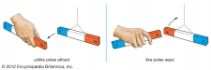
There are forces between the poles. They are called
magnetic forces. The forces create a magnetic field.
Magnetic fields are areas affected by magnets. Every
magnet is surrounded by a magnetic field.
Uses For Magnets
One of the first uses of magnets was in compasses. A compass is a needle-shaped magnet. It is free to spin around. The planet Earth is a giant magnet. The Earth's north pole attracts the compass's south pole. This makes the compass needle point north.
Magnets are found in many places. Magnets hold papers on refrigerator doors. They also hold the doors shut. Credit cards have a magnetic strip. Many electric motors use electromagnets as well.

TEXT STRUCTURE LESSON GUIDE©
This page must be completed for every text students read.
Story/Article/Chapter: Magnets and Magnetism
TEKS 5.6D-Design a simple experimental investigation that tests the effect of force on an object.
TEKS 4.6-D-Design a descriptive investigation to explore the effect of force on an object such as a push or a pull, gravity, friction, or magnetism.
TEKS 3.6B-Demonstrate and observe how position and motion can be changed by pushing and pulling objects such as swings, balls and wagons.
Process TEKS: 5.2A, 5.4A, 4.2C, 4.2D, 3.2D
Text Structure(s): {Please choose cause and effect, problem and solution, and/or comparison text structure to organize the lesson.}
Overall Text Structure: Cause and Effect
Science:
Paragraphs 9 & 10: Cause and Effect

Introduction to selection: {Make sure to introduce the text structure as you introduce the selection}

Today, we are going to read about magnetism, one of the main forces of nature.

Our science focus will be on the poles of a magnet and what forces they create.

Signaling Words in Passage:  Cause/Effect: caused by, make, form, because | CHECKPOINT #1  Vocabulary Words: {Identify words your students would not understand}  force, magnetism, electromagnet, attract, repel, poles
CHECKPOINT# 2
Overall Main/Key Idea for whole selection:
{Make sure to use the text structure specific main idea stem that matches the overall text structure for the passage. For example, for cause and effect use: The cause is _____ and the effect is ______.}

The causes are tiny particles called electrons. The effect is magnetism.
Summary for the whole selection: {Make sure to extend the main idea and include details supporting each part e.g., cause, problem, and solution}

The causes are tiny particles called electrons. Many of the electrons spin in the same direction. All the tiny magnetic forces from the electrons add together. The effect is magnetism. It is one of the main forces of nature.
Summary Multiple Choice Practice Question: {Create a multiple-choice question asking students to select the best summary}
What is the BEST summary for the selection?
- Magnetism is caused by tiny particles called electrons. Everything in the world is made up of units called atoms. Atoms are made up of electrons and other particles. The electrons spin around the atom's center. This is called the nucleus.
- Magnets exist in nature. Certain rocks are magnets. One type of magnetic rock is lodestone. Magnetism works over a distance. A magnet does not have to be touching an object to pull it.
- Tiny particles called electrons spin in the same direction. All the tiny magnetic forces from the electrons add together. This creates magnetism. It is one of the main forces of nature.
- The spinning electrons form tiny magnetic forces. Sometimes, many of the electrons spin in the same direction. Then all the tiny magnetic forces from the electrons add together.
SCIENCE: TEKS 5.6D, 4.6D, 3.6B, Process TEKS
CHECKPOINT# 2
Main/Key Idea for paragraphs 9 & 10 : (cause and effect)

The causes are the two poles of the magnets. The effect is magnets attract or push away other hard magnets.
Summary for paragraphs 9 & 10: {Make sure to extend the main idea and include details supporting each part e.g., cause, effect}

The causes are the two poles of the magnets. The poles are found at opposite ends of the magnet. They are called the north and south pole. The effect is magnets attract or push away other hard magnets. North poles attract the south poles of other magnets. They push away other north poles. In the same way, south poles attract north poles. South poles push away other south poles.

CHECKPOINT #3
Inference Questions: {Use the STAAR sample question stems if needed}

- From paragraph 7 & 12, what does the interaction between the Earth, a giant magnet, and a compass reveal about the composition of Earth’s core?
- Based on paragraphs 2 & 12, magnets do not have to touch an object to pull it. What can you infer determines the distance a magnet’s force can reach?
- What testable hypothesis could be formed to classify objects based on their property of magnetism? (If an object is attracted to a magnet, then it is magnetic.)
Science STAAR Practice Questions:

1. The two pictures show part of an investigation. A magnet, a book, and a paperclip are on a sheet of lined paper. In Picture 1 a student slides a magnet closer to the book. The student holds the book still in both pictures. Which statement about this investigation can be supported by the result shown?
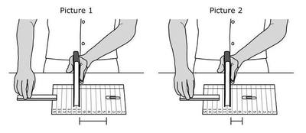

Which statement about this investigation can be supported by the result shown?

A. Work was done on the magnet, the book, and the paperclip.

B. Work was done on the magnet and the paperclip only.

C. Work was done on the magnet and the book only.

D. Work was done on the magnet only.

2. Which statement is true about the magnets shown?

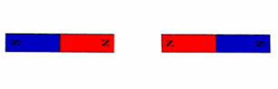

A. The magnets will attract and pull together.
B. The magnets will do nothing.
C. The magnets will repel and push apart.
D. There needs to be an iron nail.

This lesson planning page is part of three grant funded projects led by Dr. K. Wijekumar at Texas A&M University. The materials are designed to improve reading comprehension and to be used with the text structure strategy instruction in language arts, science, social studies, special education, and bilingual classrooms. Most importantly, this planning page ensures consistency of instruction horizontally and vertically aligned and overcomes contradicting instruction in textbooks.

